
June 7, 2026
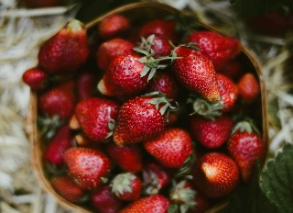

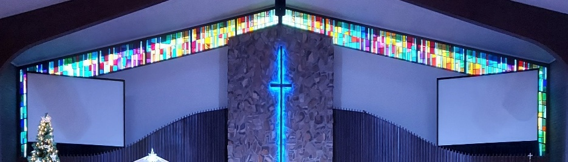
IMMANUEL LUTHERAN CHURCH

Rev. Dr. Douglas A. Krengel, Sole Pastor

Please contact Pastor Krengel for any Pastoral needs. If you need to make an appointment with Pastor Krengel - You are invited to call him on his cell phone or send him an email.

Pastor Krengel’s Cell Phone: 832-257-5437 email: krengeld@gmail.com
Church Office Email: ilc@immanuelbridgman.org Website: www.immanuelbridgman.org

Sunday Services: Traditional 8:30 am, Praise 10:45 am
Worship Services are Streamed Live on Facebook - Immanuel Lutheran Church Bridgman

Sunday Adult Bible Study 9:30 am – ROOM 6
9650 N. Church St., Bridgman, MI 49106 269-465-6031 Church Office
Church Office Hours are 8:00 am – 4:00 pm

Immanuel’s Mission Statement
Immanuel exists to connect all people to Jesus Christ, who embraces all people in His grace, so that we can serve all people in love and discover a hope that heals.
The Second Sunday after Pentecost
June 7, 2026
We pray in the Lord’s Prayer, “Thy will be done.” But what is it that God desires? The Lord expressed his desire for Israel through the public and private life of his servant, Hosea. Working through the prophet’s person, marriage, and ministry, God stated his desire in today’s text, “For I desire steadfast love and not sacrifice, the knowledge of God rather than burnt offerings” (Hosea 6:6). Thousands of years after this text was originally revealed, and thousands of miles away from Israel, the Almighty still desires the same things from his church: steadfast love and the knowledge of God. May the Holy Spirit, working through the words of Hosea, move us to respond the God’s message of Law and Gospel with such love and knowledge – now and forever. Amen.
Today’s Hymns: LSB 601, 689, 784, 915, 637, 922
Today’s Scriptures: Hosea 5:15-6:6, Romans 4:13-25, Matthew 9:9-13
Prayers of the Church for Today

Healing Needs for the Month – Please update the office with any changes.

Barb Ackerman, Harriet Fester, Terry Graves, Sharon Korcek, Denny Lawrenz, Norma Linn, Dorothy Ott, Renata Ottusch, Cheryl Petty, Irwin & Margaret Poschke, Dolly Schmaltz, Tom Ulmer, Beth Vigansky

Shut In Visitations for the Month of May: Visited and communed were Connie Ott, Donna Mach, Donna Springs, Edith Weed, Edna Holt, Harry Rock, Elizabeth Rock, Harriet Fester, Irv & Margaret Poschke, Dorothy Ott, Dorothea Crocker, Denny & Deb Lawrenz, Terry Swedenberg, Lynn & Dollie Schmaltz, Bill Gast, Lorraine & Dillon Jasper, Joanne Argue, Richard & Karen Gorske, Dave Arndt, Terry Graves, Anne Marie Mojsiejenko. Twenty-seven visits were made by the visitation team (Pastor Krengel, Betty Korcek, Paul & Deb Jaeger, Kathy Mammal, & Larry Smith.)

Immanuel’s website
Welcome Guests! Thank you for spending your time in worship with us! Please take some time to share your contact information by signing the guest book in the narthex.
CHURCH NEWS

NOTE: The Strawberry Social Sign-ups are in back of the Narthex!
June 14, 2026 at 10:00 AM Unity Service Celebrating Immanuel’s 130th Anniversary!

Flowers on the Altar today are in memory of Rich Vonk from Sherry and Family.

Congratulations to ALL the graduates, well done! Be sure to check out the Graduate Page!

June’s Calendar is available in the Narthex – Get yours today!

SUNDAY ADULT BIBLE STUDY WILL BE IN ROOM 6 FOR THE SUMMER! We will be studying Genesis.

Stand for Life Walk – We will be holding our Walk this June 20, 2026, from 11:30 – 2:00 pm, with a Luncheon & Fellowship afterward. Wipes & Diaper (sizes 5&6 requested).
Free for ALL in the Gym Drop Off Donations June 23, 24 & 25 from 2:00 – 6:00 pm, The Free for All will start June 26 & 27 from 8:00 – 2:00 pm.
Operation Christmas Child UPDATE –Now that summer is nearly here, Christmas seems far away. But we hope to continue collecting for Operation Christmas Child all year. In June we are gathering sunglasses, puzzles, jump ropes, and yo-yos. The Outreach Committee has an ambitious goal of filling 150 shoeboxes in 2026; every item donated helps! Thank you!
Sewing for Missions will meet next on Friday, June 12 at 9:00am. And here is a secret: we don't actually sew when we meet - we tie knots and lay out fabric. So even if you do not sew, you can still help prepare quilts for Lutheran World Relief! Please feel invited to join in.

VBS 2026 – Theme Emerald Crossing – July 13-16 We are looking for volunteers! Please contact Shannon Jones if you are interested. Volunteer sign-ups are in the back of the Narthex, fill out and turn into the Church Office.

VBS 2026 – Registration is Open to sign-up your kiddos and grandkids ages 4-12! Forms are in the back of the Narthex and can be turned into the Church Office.

The Bridges Bags for our Shut ins are available for the summer!

FYI: Planning Committee Members are Pastor Krengel, Kurt Hanke, Al Barker, Devon Girton, SueEllen Klein, Rich Kubsch and Sherri Vonk. If you have any questions, please reach out to one of them.

We are looking for volunteers for a Tween/Teen (11-18 yrs) Bible Study in the Upper Room on Sundays at 9:30 am. We have a curriculum ready and available. Please contact the church office if you are interested.
Please Note: The receptacles at the front of the church are only for the communion cups only, no trash please!
Last Sunday’s Attendance: 70 - 8:30 am, 50 - 10:45 am
Sunday Bible Study – 12
Thursday Bible Study – 7

Finance News

May 31, 2026, offerings and donations:
Offering Envelopes: $6229.00 Year to date: $116,520.00

Thank You for your Contributions!
Electronic Giving is Available on Immanuel’s Website on the Main Page.

www.immanuelbridgman.org





Congratulations to ALL the Graduates this year!
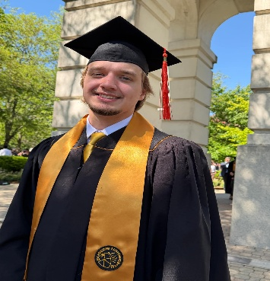
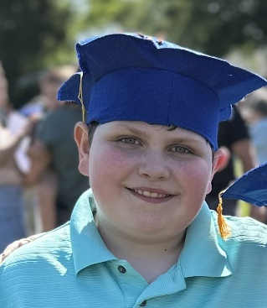


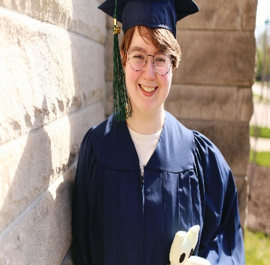
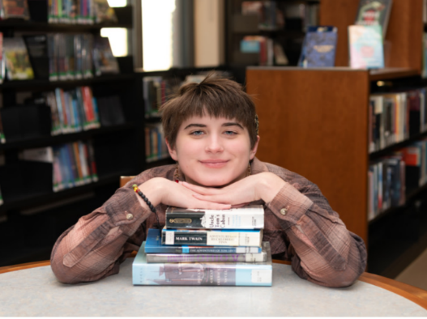
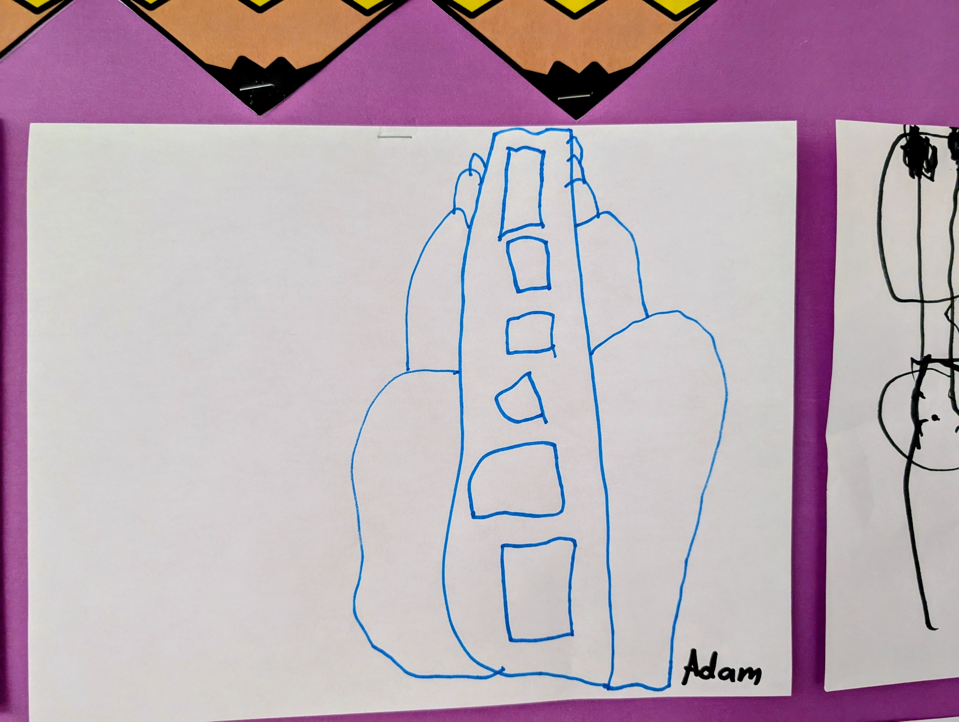
Faith Butler
Eighth Grade Graduation
Daughter of Shannah Smith
Granddaughter of Amie & Larry Smith
Colt Smith
Fourth Grade Graduation
Son of Amie & Larry Smith
Trystan Smith
High School Diploma
Grandson of Amie & Larry Smith
Megan Oldenburg
High School Diploma
Daughter of Chad & Sara Oldenburg
Will Ott
Bachelor’s in Computer Engineering
Son of Tiffany & Tim Ott
Anna Louise Piller
High School Diploma
Granddaughter of Harold & the late Patricia Heyn

