June 28, 2026


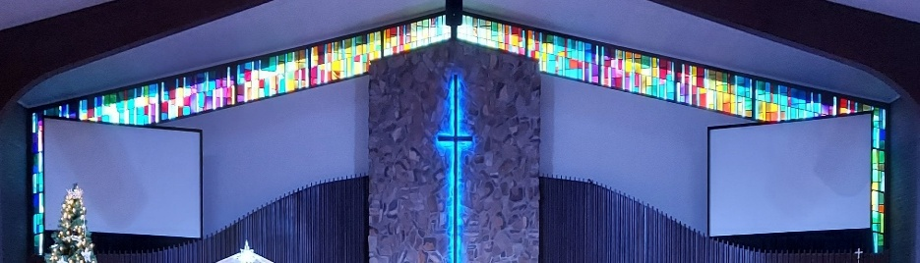
IMMANUEL LUTHERAN CHURCH

Immanuel’s Mission Statement
Immanuel exists to connect all people to Jesus Christ, who embraces all people in His grace, so that we can serve all people in love and discover a hope that heals.
The Fifth Sunday after Pentecost
June 28, 2026
In athletic events competitors are often called upon to compete one-on-one with their opponents. “Singles” in tennis, racquetball, squash, badminton, and table tennis, two competitors face each other. Similarly in wrestling, judo, karate, taekwondo, boxing, wrestling, and fencing, two athletes join a controlled version of combat in order to identify the champion. In this morning’s Old Testament lesson such a one-on-one, face-to-face, confrontation also happened; however, it was the confrontation was theological instead of athletic. To which prophet in Israel should the king, and the people, listen? Hananiah? Or Jeremiah? In these last days, Christian people are often confronted with supposed tellers of the truth. May the Lord endow his people today with the spiritual gift of discernment so that we may identify the true prophetic words of God and live in light of them – now and forever. Amen.
Today’s Hymns: LSB 729, 681, 734 vs 1,3,4, LW 499
Today’s Scriptures: Jeremiah 28:5–9, Romans 7:1–13, Matthew 10:34–42

Prayers of the Church for Today

Barb Ackerman receiving treatments in Chicago
Harriet Fester

Healing Needs for the Month – Please update the office with any changes.

Terry Graves, Sharon Korcek, Denny Lawrenz, Norma Linn, Dorothy Ott, Renata Ottusch, Cheryl Petty,
Irwin (Irv) Poschke and Margaret Poschke, Dolly Schmaltz, Tom Ulmer, Beth Vigansky

Rev. Dr. Douglas A. Krengel, Sole Pastor

Please contact Pastor Krengel for any Pastoral needs. If you need to make an appointment with Pastor Krengel - You are invited to call him on his cell phone or send him an email.

Pastor Krengel’s Cell Phone: 832-257-5437 email: krengeld@gmail.com
Church Office Email: ilc@immanuelbridgman.org Website: www.immanuelbridgman.org

Sunday Services: Traditional 8:30 am, Praise 10:45 am
Worship Services are Streamed Live on Facebook - Immanuel Lutheran Church Bridgman

Sunday Adult Bible Study 9:30 am – ROOM 6
9650 N. Church St., Bridgman, MI 49106 269-465-6031 Church Office
Church Office Hours are 8:00 am – 4:00 pm

Welcome, guests! We have prepared a small gift bag from the back table to share with you.
Please take a moment to sign the guest book in the narthex so we can stay connected.
Thank you for visiting — we hope to see you again soon!

Immanuel’s website
CHURCH NEWS

Thank You – Flautist Lori Sukupchak for her beautiful contributions to the 8:30 am Service this morning.

PLEASE NOTE: the Summer Handbells Practice will be held at Trinity Glendora beginning THIS coming Monday, June 22, starting at 6:30 – 7:30 pm throughout the summer.
Thanks to everyone who helped work the Free for ALL this weekend and all the prep work this last week!
SUNDAY NIGHT JUNE 28, 2026 from 7:00 - 7:30 p.m. ON KKHT 100.7 FM "THE WORD" To stream broadcasts from outside the Houston area go to kkht.com and click the "Listen Live" button. "ART, BASEBALL, AND THE MISSION FIELD" How can art, sports, and community involvement become opportunities for sharing the gospel? In this episode, Rev. Dr. Doug Krengel visits with Jordan Boessling, Director of Creative Communication and Community Connections at Christ Lutheran Church in Austin, Texas.

Operation Christmas Child UPDATE –Now that summer is here, Christmas seems far away. But we hope to continue collecting for Operation Christmas Child all year. In June we are gathering sunglasses, puzzles, jump ropes, and yo-yos. The Outreach Committee has an ambitious goal of filling 150 shoeboxes in 2026; every item donated helps! Thank you!
Bridgman Day is July 11, 2026 – We will be out on the front lawn from 12:45 – 2:00 pm. The Parade starts at 2:00pm, we will have a vintage truck in the parade for Immanuel, also the Praise Team will be singing in the front yard, and we will have ice cream treats and water for the public. We would love help with setting up tables and chairs. And if anyone has a couple of pop-up tents we could borrow would be great – just let SueEllen Klein or the Church Office know. Thanks!
VBS 2026 – Theme Emerald Crossing – July 13-16 We are looking for volunteers! Please contact Shannon Jones if you are interested. Volunteer sign-ups are in the back of the Narthex, fill out and turn into the Church Office.
There is a Meeting TODAY after the 10:45 am service – be there or be square!

VBS 2026 – Registration is Open to sign-up your kiddos and grandkids ages 4-12! Forms are in the back of the Narthex and can be turned into the Church Office.

Sunday, July 19, 2026 at 6:00 pm -- Trinity Lutheran Church of Glendora is presenting a concert of Reggie & Ladye Love Smith for an evening of worship in music. They are Grammy award-winning vocalists featured on Gaither Homecoming television specials will be held at the Howard Performing Arts Center, on the campus of Andrews University – 4160 East Campus Circle Drive, Berrien Springs, MI. Tickets: 269-471-3560 or 888-467-6442 or are available online at howard.andrews.edu $20 Adults, $10 Children 10& Under.

We are looking for volunteers for a Tween/Teen (11-18 yrs) Bible Study in the Upper Room on Sundays at 9:30 am. We have a curriculum ready and available. Please contact the church office if you are interested.
“Psalms for Summer” will meet NEXT TUESDAY and following Tuesdays this summer at 12:45-2pm on the picnic tables by the children’s play area in Harbert Community Park, 13495-13535 Red Arrow Hwy, Sawyer, MI 49125. See you there! Bring a Bible and a friend! Questions? Please contact Pastor Tom Fischer, 248.495.3723.

Are you a good reader? Outspoken? Attend the 8:30 am Service? We are looking to grow our layreader pool? Why not jump in? If interested just stop in or call the Church Office!!

The Office is also looking for Confirmation Pictures from 2000, 2006-2019 to add to the Confirmand Book! Any help is appreciated!
Last Sunday’s Attendance: 80 - 8:30 am, 44 - 10:45 am
Sunday Bible Study – 15
Thursday Bible Study – 5

Finance News

June 21, 2026, offerings and donations:
Offering Envelopes: $5,278.00.00 Year to date: $172,762.00

Thank You for your Contributions!
Electronic Giving is Available on Immanuel’s Website on the Main Page.
www.immanuelbridgman.org

