September 27, 2026
Proverbs 28:5
⁵Evil men do not understand justice, but those who seek the Lord understand it completely.


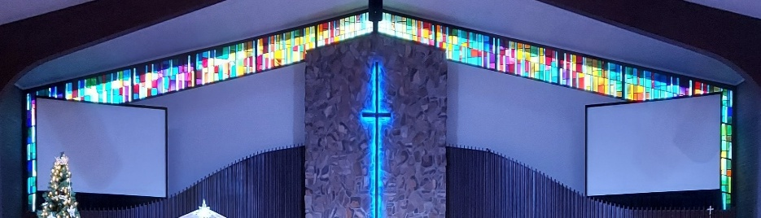

IMMANUEL LUTHERAN CHURCH
If we confess our sins, he is faithful and just to forgive us our sins and to cleanse us from all unrighteousness.
1 John 1:9

Immanuel’s Mission Statement
Immanuel exists to connect all people to Jesus Christ, who embraces all people in His grace, so that we can serve all people in love and discover a hope that heals.

As We Gather
“That’s not fair!” Children often speak these words to their parents, their teachers, their coaches. However, it is not just children who make such claims. In this morning’s Old Testament lesson, the prophet Ezekiel responds to churchgoers’ claims that God is fickle, unfair, and unjust. As we study God’s Word together, may we all learn that the reality of justice is quite the opposite of what these churchgoers claim: really, we sinful people are guilty of trying to blame others for our sins. God teaches us through His prophets that God is indeed just. Thanks be to God, for Christ’s sake, He is also very patient and merciful with us fallen sinners as He calls us to repent and to receive real life now and forever.
The Eighteenth Sunday after Pentecost
September 27, 2026
Today’s Hymns: LSB 533, 614, 941, 824
Today’s Scriptures: Ezekiel 18:1–4, 25–32; Philippians 2:1–18, Matthew 21:23–32
8:30 am Lay Reader: Kathy Hanke

Prayers of the Church for Today– Please update the office with any changes.
Kit Campbell (illness – nephew of the Jaegers), Myra Clark (breathing issues), Bob & Donna Griggs (cancer treatment & complications from a fall), friends of the Dehrings, Norma Linn (recovering from a fall), Family of Robert Scott (Larry Smith’s Uncle), Kathi Sharp (cancer) – the Dehrings. Terry Swedenberg & Gustuv Springs (brother & husband of Donna Springs). A prayer of thanksgiving for Beth Vigansky Ciuzio; Beth had her surgery, and everything went well! They found no other evidence of cancer, so she is considered in remission. No more Chemo! God is good! Thank you all for your concern and prayers. They were all so very much appreciated. A big thank you to our awesome God! Barb Ackerman, Dorthea Crocker, Harriet Fester, Jere Dehring, Terry Graves, Caleb Harrington, Irene High – Stage 4 Stomach cancer, Sharon Korcek, Denny Lawrenz, Manfred Moneta, Dorothy Ott, Renate Ottusch, LeeAnn Plukas– friend the Jaegers, Irwin (Irv) Poschke

Immanuel’s website
Rev. Dr. Douglas A. Krengel, Sole Pastor

Please contact Pastor Krengel for any Pastoral needs. To make an appointment with Pastor Krengel, call his cell phone, email him, or contact the church office.

Pastor Krengel’s Cell Phone: 832-257-5437 Email: krengeld@gmail.com
Church Office Email: ilc@immanuelbridgman.org Website: www.immanuelbridgman.org

Sunday Services: Traditional 8:30 am, Praise 10:45 am
Worship Services are Streamed Live on Facebook - Immanuel Lutheran Church Bridgman
Sunday Adult Bible Study 9:30 am – ROOM 6 Studying Genesis

Sunday School “The Rock” 9:30 – 10:30 am

9650 N. Church St., Bridgman, MI 49106 269-465-6031 Church Office
Church Office Hours: Monday - Friday from 8:00 am – 4:00 pm

Welcome, guests! We have prepared a small gift bag from the back table to share with you.
Please take a moment to sign the guest book in the narthex so we can stay connected.
Thank you for visiting us. We hope to see you again soon!

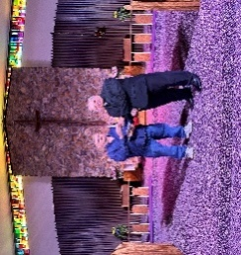
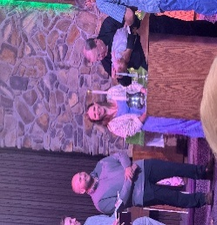
CHURCH NEWS

How blessed we were this past Sunday!

We rejoiced as Evelynn Grace Soulard received the gift of Holy Baptism.
Congratulations to Evelynn, her parents, and her entire family as they celebrate this special day in her faith journey. We were also delighted to welcome William (Bill) Wise as a Confirmed Member of our congregation. We give thanks to God for Bill and pray that He richly blesses his continued walk in faith. Please join us in celebrating these wonderful blessings and keeping Evelynn, Bill, and their families in your prayers. ✝️🙏💙

Be sure Check out the October Calendar, Birthday & Wedding Anniversaries! Congratulations to Alan & Susan Foster on 40 yrs of Wedded Bliss and to Ariel & Cody Womeldorf on 5 yrs of Blissful Marriage, along with all the other Wedding Anniversaries and Birthdays!

Bible Studies here at Immanuel - available: Sunday @ 9:30 am, Monday @ 10:00 am, Wednesday @ 10:00 am.
Evening Adult Bible Study at Trinity Sawyer Wednesday @ 5:30 pm text Pastor Wittig at (989)996-5353.

Trinity Lutheran, Glendora youth will have their annual car hop fundraiser TODAY - Sunday, September 27th from 5:00-7:00. The menu includes a burger, chips, watermelon, and a root beer float. The suggested donation is $8.00/meal. Come support the youth group and have a great meal and time of fellowship! The church's address is 1733 W. Glendora Rd, Buchanan.

WOW! Thanks to all who donated school supplies to Operation Christmas Child in August. In September, we are collecting cars & trucks, dolls, jump ropes, sunglasses, puzzles, and card games. Every child loves to receive fun items! The Outreach Committee thanks you for every donation as we work toward assembling the shoeboxes in the fall.

A few boxes are needed! Sewing for Missions is preparing to ship our quilts to Lutheran World Relief. We could use a few more boxes, approximately 20" X 15" X 15". If you have a box to spare, please bring it to the church office. Thank you!

Lutheran Singles Weekend – Friday, October 9-11, 2026, at Advent Evangelical Lutheran Church, Zionsville, IN. See the Bulletin Board outside the Church Office for more details.

LWML Fall Rally – October 11, 2026, at St. Paul Lutheran Church, 305 W. State St., Cassopolis. Registration: 2:00 pm Program: 2:30 p.m. Flyers are in the Narthex for more information.

Please Note the next Voters’ Meeting is Sunday, October 25, 2026, after Church. Please submit Board Reports to the Church Office by October 5, 2026, to allow time to assemble the packets and make them available to the congregation on October 11, 2026.

With the Voter’s Meeting coming up in October, now is the time to consider joining a board/team: Administration, Altar Guild, ECDC, Education (Sunday School), Elders, Fellowship, Finance, LWML, Outreach, Safety, Trustees, Worship. All members of Immanuel Lutheran Church are welcome to join; contact the Church Office for more information!

The Circuit Reformation Service, November 1, 3:30 p.m., Immanuel Lutheran Church, Bridgman - here before we know it!

REMINDER – Please turn off the lights in the Sanctuary when done.

Last Sunday’s Attendance: 65 - 8:30 am; 89 - 10:45 am
Bible Studies: 19 (Sun), 8 (Mon), 7 (Wed), (Thurs)
Online views:

FINANCE UPDATE

Church Mid-Year 2026 Surplus / (Deficit) ($39,644)
Child Care Mid-Year 2026 Surplus / (Deficit) ($70,609)

Thank You for your Contributions!
Electronic Giving is Available on Immanuel’s Website on the Main Page.
www.immanuelbridgman.org

