September 6, 2026
Ephesians 4:32
³²Be kind to one another, tenderhearted, forgiving one another, as God in Christ forgave you.

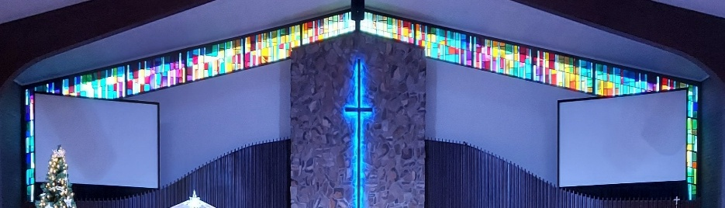


IMMANUEL LUTHERAN CHURCH

Immanuel’s website
Rev. Dr. Douglas A. Krengel, Sole Pastor

Please contact Pastor Krengel for any Pastoral needs. If you would like to make an appointment with Pastor Krengel - You are invited to call him on his cell phone or send him an email or contact the church office.

Pastor Krengel’s Cell Phone: 832-257-5437 email: krengeld@gmail.com
Church Office Email: ilc@immanuelbridgman.org Website: www.immanuelbridgman.org (recently updated)

Sunday Services: Traditional 8:30 am, Praise 10:45 am
Worship Services are Streamed Live on Facebook - Immanuel Lutheran Church Bridgman
Sunday Adult Bible Study 9:30 am – ROOM 6 Studying Genisis 2

Sunday School “The Rock” 9:30 – 10:30 Starts back up on September 20, 2026

9650 N. Church St., Bridgman, MI 49106 269-465-6031 Church Office
Church Office Hours: Monday - Friday from 8:00 am – 4:00 pm OFFICE IS CLOSED MONDAY FOR LABOR DAY

Welcome, guests! We have prepared a small gift bag from the back table to share with you.
Please take a moment to sign the guest book in the narthex so we can stay connected.
Thank you for visiting us. We hope to see you again soon!

Immanuel’s Mission Statement
Immanuel exists to connect all people to Jesus Christ, who embraces all people in His grace, so that we can serve all people in love and discover a hope that heals.

The Thirteenth Sunday after Pentecost
September 6, 2026
Labor Day is tomorrow. While Labor Day is a national holiday, it is not a liturgical festival, feast, commemoration, or observation within the Lutheran Church – Missouri Synod, the denomination which Immanuel joined 130 years ago. Abraham, Isaac, Jacob, and finally Joseph are the descendants of the first couple. Before Joseph dies at age 110, he reconciles with his brothers – yes, the brothers who sold him into slavery. By God’s direct intervention in history, Joseph ascended from an imprisoned slave to second unto Pharoah. By the labor of Jesus Christ, Joseph was able to forgive his brothers evil deeds and dishonest ways. May the risen Christ bring us such a blessing to our broken relationships today.
Today’s Hymns: LW 317, LSB 758, 956, 709, 501, 854
Today’s Scriptures: Genesis 50:15-21, Romans 14:1-12, Matthew 18:21-35
8:30 am Lay Reader: Nancy Seldomridge

Prayers of the Church for Today
Greg Eber (Heart Attack), Bob & Donna Griggs (cancer treatment & complications from a fall) friends of the Dehrings, All New Troy HS Class of 1966 buddies who are dealing with health issues, loss, etc. – the Dehrings. Please pray for the ECDC Preschool to fill up for the start of the school year.

Healing Needs for the Month – Please update the office with any changes.
Barb Ackerman, Dorthea Crocker, Harriet Fester, Jere Dehring, Terry Graves, Irene High – Stage 4 Stomach (cousins of Richard & Debbie Ruff), Sharon Korcek, Denny Lawrenz, Manfred Moneta, Dorothy Ott, Renata Ottusch, LeeAnn Plukas– friend of Paul & Deb Jaeger, Irwin (Irv) Poschke and Margaret Poschke, Beth Vigansky Ciuzio

CHURCH NEWS

ANNOUNCEMENT: SPECIAL VOTERS MEETING TODAY AFTER THE 8:30 AM SERVICE.
TODAY, after the second service, you are invited to attend a Sunday School Planning Meeting in the Sunday School room.
Please Note that Outreach has rescheduled its monthly Meeting to Saturday. September 12 at 9:15, a Visitation Meeting will follow at 10:15. Anyone interested in Outreach or Visiting our Shut-Ins are welcome to attend.

Share: ECDC has Openings for 3- and 4-year-old Private Pay Preschool and Primary Room Childcare.
Please let Chris Damaske (269-466-2110) know if you are unable to deliver the Bridges bag you have signed out for the month, so they can be delivered in a timely manner. Thank You!
WOW! Thanks to all who donated school supplies to Operation Christmas Child in August. In September, we are collecting cars & trucks, dolls, jump ropes, sunglasses, puzzles, and card games. Every child loves to receive fun items! The Outreach Committee thanks you for each and every donation you make as we move towards assembling the shoeboxes in the fall.
.
Prayer Pillow Progress! We need a few volunteers to stuff the pillows and do a bit of hand sewing. Please speak with Kim Schmitz or Elizabeth Emery if you can help.
Lutheran Women’s Missionary League (LWML) is planning its next meeting, an Ice Cream Social, for September 8, 2026, at 6:30 p.m. This will be a Reorganization/Planning Meeting. LWML Sunday is the 1st Sunday in October.
Wednesday Bible Study w/Elsie Hanke starts September 9th at 10:00 AM. Monday Bible Study w/Patty Green starts September 14 at 10:00 AM. ALL are welcome; both meet in the (Lower) Upper Room just past the Church Office.
Our Youngish Adult Bible Study will be September 9th at 5:30 p.m. at Trinity, Sawyer. We are planning to have light snacks as we continue a Bible Study series on "God's Story." Our study for the 9th will focus on submitting to the Lord's Will for our lives. We would love to have youngish adults (like 20s/30s, but no set limits) from our circuit congregations join us. If you have anyone who is interested, please have them text me at (989)996-5353.

Attention all Board members of Immanuel. Please submit your 2027 planned budget request to Elizabeth Emery, emazeemery@outlook.com, no later than September 11th, so that Finance has time to compile and prepare the 2027 Budget for the Voters Meeting in October. Please pray about your budget request, as Immanuel is currently running a deficit.

Patriotic Service is scheduled for September 13, 2026. Sign-ups for food and attendance are in the Narthex!

Sunday School will resume on September 20th from 9:30-10:30. All ages welcome!
Interested in learning more about the Christian faith and church membership? The 6-week Adult Confirmation Class will begin on September 20 following the 10:45 a.m. service. We invite all interested adults to join us.

Congregational Planning Retreat, Saturday, September 26, from 9 AM to 1 PM. Copies of the Draft Constitution are in the back of the Narthex; please grab one to review prior to the retreat. See the church office if you need a copy.

Lutheran Singles Weekend – Friday, October 9-11, 2026 at Advent Evangelical Lutheran Church, Zionsville, IN. See the Bulletin Board outside the Church Office for more Details.

Please Note the Next Voter’s Meeting is Sunday, October 25, 2026 after Church. Board Reports must be submitted to the Church Office by October 5, 2026, to allow time to assemble the packets and make them available to the congregation on October 11, 2026.
Last Sunday’s Attendance: 84 - 8:30; 50 - 10:45 am
Adult Bible Study - 15
Online: views: 6
Thursday Bible Study - 8

FINANCE UPDATE
August 30, 2026, offerings and donations:
Offering Envelopes: $8,006.00 Year to date: $234,040.00

Thank You for your Contributions!
Electronic Giving is Available on Immanuel’s Website on the Main Page.
www.immanuelbridgman.org

