October 11, 2026
James 2:19
¹⁹You believe that God is one; you do well. Even the demons believe—and shudder!

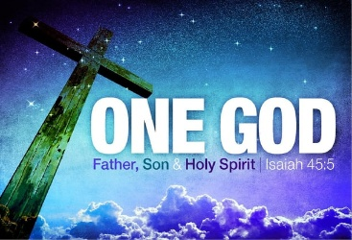
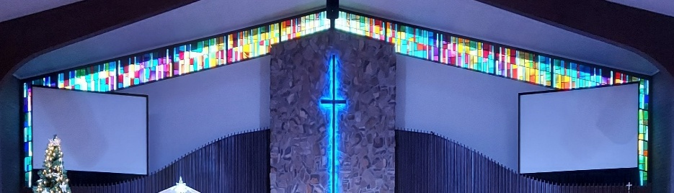
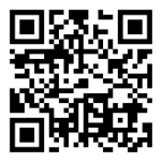
IMMANUEL LUTHERAN CHURCH

Immanuel’s Mission Statement
Immanuel exists to connect all people to Jesus Christ, who embraces all people in His grace, so that we can serve all people in love and discover a hope that heals.

As We Gather
This morning we will focus our attention on the Old Testament lesson from Isaiah, where we read the true and triune God say, “For I am the LORD your God, the Holy One of Israel, your Savior” (43:3). There are many religions that believe in many gods. Other individuals believe in no god/gods. The faith revealed in the Bible teaches us that there is one true God. This one true God interacts with his creation by redeeming, protecting, and calling individuals from the ends of the earth. May the Holy Spirit bring us to rightly confess the one God, the Holy One of Israel. Amen.
The Twenty-first Sunday after Pentecost
October 18, 2026

Today’s Hymns: LSB 905, 813 odd vs only, 783 even vs, 851, 726, 643
Today’s Scriptures: Isaiah 43:1–71, Thessalonians 1:1–10, Matthew 22:15–22

8:30 am Lay Reader:

Prayers of the Church for Today
Jim Baracin (fall) - Karen Oldenburg’s Brother, Carol Moneta, Edie Paul (hospital)

Prayers for the Month– Please update the office with any changes.
Barb Ackerman, Dorthea Crocker, Kathi Sharp (cancer) – the Dehrings. Harriet Fester, Terry Graves, Irene High – Stage 4 Stomach cancer, Sharon Korcek, Denny Lawrenz, Dorothy Ott, Renate Ottusch, LeeAnn Plukas – friend of the Jaegers, Irwin (Irv) Poschke, Terry Swedenberg & Gustuv Springs (brother & husband of Donna Springs).

Rev. Dr. Douglas A. Krengel, Sole Pastor

Please contact Pastor Krengel for any Pastoral needs. To make an appointment with Pastor Krengel, call his cell phone, email him, or contact the church office.

Pastor Krengel’s Cell Phone: 832-257-5437 Email: krengeld@gmail.com
Church Office Email: ilc@immanuelbridgman.org Website: www.immanuelbridgman.org

Sunday Services: Traditional 8:30 am, Praise 10:45 am
Worship Services are Streamed Live on Facebook - Immanuel Lutheran Church Bridgman
Sunday Adult Bible Study 9:30 am – ROOM 6 Studying Islam

Sunday School “The Rock” 9:30 – 10:30 am

9650 N. Church St., Bridgman, MI 49106 269-465-6031 Church Office
Church Office Hours: Monday - Friday from 8:00 am – 4:00 pm

Bible Study Opportunities: Monday & Wednesday @ 10:00 am, Breakfast with Jesus at Rochefort’s in Bridgman on Thursdays at 8:00 am. Evening Adult Bible Study at Trinity Sawyer Wednesday @ 5:30 pm.

Immanuel’s website
Welcome, guests! We have prepared a small gift bag from the back table to share with you.
Please take a moment to sign the guest book in the narthex so we can stay connected.
Thank you for visiting us. We hope to see you again soon!

CHURCH NEWS

Administration Bd. Meeting October 19 @ 7:00 pm

Spiritual / Business Council Meetings October 20 @ 6:00 pm / 7:00 pm

Annual Chicken Dinner at Trinity Lutheran of Glendora, Wednesday, October 21, 2026. Call Carolyn for Tickets by October 18th at 269-422-1311. Adults $15 / Children (4-10 yrs) $8. See the Flyer on the Bulletin for more Details.

Please note the next Voters’ Meeting is Sunday, October 25, 2026, after the Church Service. We will also be having a Pastor Appreciation luncheon. Please take a copy of the Voters Meeting Packet in the back of the Narthex for your review.

Don’t forget to CHANGE YOUR CLOCKS on Saturday, October 31st … fall back one hour.

The Circuit Reformation Service, November 1, 3:30 p.m., Immanuel Lutheran Church, Bridgman. Dinner to follow,

Operation Christmas Child's final month for donations is here! We are collecting dolls, trucks/cars, puzzles, card games - fun things that kids anywhere love to receive. AND please save the date - November 14th - for a PEW Party. You are invited to help Pack Operation Christmas Child shoeboxes, Eat a dinner together, and Watch a family-friendly movie in the Life Center. The fun starts at 5:00 pm. Hope to see you there!

With the Voters’ Meeting coming up in October, now is the time to consider joining a board/team: Administration, Altar Guild, ECDC, Education (Sunday School), Elders, Fellowship, Finance, LWML, Outreach, Safety, Trustees, Worship. All members of Immanuel Lutheran Church are welcome to join; contact the Church Office for more information!

Would you be interested in an evening Bible study at Immanuel? We are gauging congregational interest in starting a new Bible study led by Oscar Delgado and Larry Smith on Tuesdays at 6:00 p.m. If you are interested, please sign up in the back of the Narthex, contact the church office, or share your input with us. Your feedback will help us determine whether enough interest exists to begin this bible study.

Church text message opt-in forms are in the back of the Narthex.

We will be updating the church mailboxes in the coming weeks. Please watch for more information.

Visitation Scheduling has been turned over to the Church Office, so if anyone needs to be added or removed, please call the office.

Bridges Bags are available to take out – Please return them by the 3rd Sunday of each month, so they can be repacked in a timely manner.

Last Sunday’s Attendance: - 8:30 am; - 10:45 am
Bible Studies: 19 (Sun), (Mon), (Wed), (Thurs)
Online views:

FINANCE UPDATE
October 11, 2026, offerings and donations:
Offering Envelopes: $.00 Year to date: $.00
Sacristy Repairs Raised: $.00

Thank You for your Contributions!
Electronic Giving is Available on Immanuel’s Website on the Main Page.
www.immanuelbridgman.org

