August 2, 2026
Colossians 3:2 Set your minds on things that are above, not on things that are on earth.

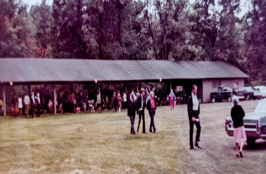
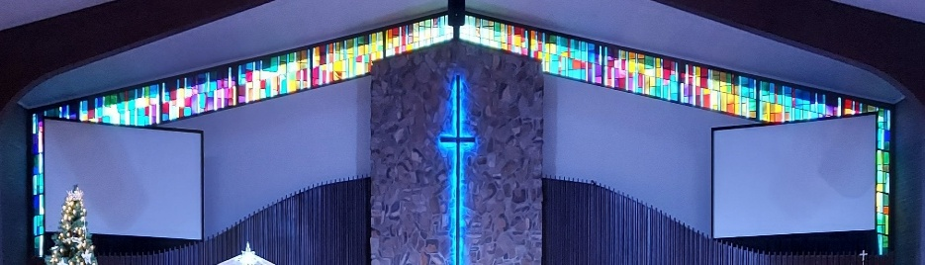

IMMANUEL LUTHERAN CHURCH

Immanuel’s Mission Statement
Immanuel exists to connect all people to Jesus Christ, who embraces all people in His grace, so that we can serve all people in love and discover a hope that heals.

The Ninth Sunday after Pentecost
August 2, 2026
How much is enough? One car? Two cars? One house? Two houses? One boat? Two boats? In the miracle of the feeding of the 5,000 the disciples looked at the situation and reasonably concluded that two fish and five loaves of bread were not enough to supply the needs of the great crowd that had assembled to hear Jesus preach and teach. Jesus disagreed with his disciples’ point of view. When our Lord looked upon the humble resources of two fish and five loaves of bread, he concluded that it was plenty. Jesus took the few resources that were at hand and multiplied them thousands of times over. So much was provided to eat by Jesus that there was lots of food remaining after the meal was done. May the Holy Spirit demonstrate to us today that God still provides for our needs with an abundance of blessing. Not do our bodies receive their nutrients, but God also generously forgives us all our sins for the sake of his Son, Jesus Christ, our Lord. May we see the blessings that God has so generously provided for us this day and forever. Amen.
Today’s Hymns: LSB 703, 774, 642, 815, 690, 809
Today’s Scriptures: Isaiah 55:1–5, Romans 9:1–13, Matthew 14:13–21
Lay Reader: Kim Schmitz

Prayers of the Church for Today
Sally Burgess (Husband passed) and Family for their loss.
Jere Dehring is recovering from infection.
Renee Green (Husband Art passed/Andy Green’s brother) Andy & Patti Green Family for their loss.
Patti Krablean (Larry Smith’s Aunt displaced due to tornado damage in Menasha WI).
Manfred Moneta – shoulder surgery.
LeeAnn Plukas for healing has internal bleeding – friend of the Paul & Deb Jaeger

Immanuel’s website
Rev. Dr. Douglas A. Krengel, Sole Pastor

Please contact Pastor Krengel for any Pastoral needs. If you would like to make an appointment with Pastor Krengel - You are invited to call him on his cell phone or send him an email or contact the church office.

Pastor Krengel’s Cell Phone: 832-257-5437 email: krengeld@gmail.com
Church Office Email: ilc@immanuelbridgman.org Website: www.immanuelbridgman.org (recently updated)

Sunday Services: Traditional 8:30 am, Praise 10:45 am
Worship Services are Streamed Live on Facebook - Immanuel Lutheran Church Bridgman
Sunday Adult Bible Study 9:30 am – ROOM 6 Studying Genisis 2

9650 N. Church St., Bridgman, MI 49106 269-465-6031 Church Office
Church Office Hours: Monday - Friday from 8:00 am – 4:00 pm

Welcome, guests! We have prepared a small gift bag from the back table to share with you.
Please take a moment to sign the guest book in the narthex so we can stay connected.
Thank you for visiting us. We hope to see you again soon!

Healing Needs for the Month – Please update the office with any changes.
Barb Ackerman, Dorthea Crocker, Harriet Fester, Terry Graves, Irene High – Stage 4 Stomach cancer & Mike High – Jacob’s Disease on Hospice (cousins of Richard & Debbie Ruff), Sharon Korcek, Denny Lawrenz, Dorothy Ott, Renata Ottusch, Cheryl Petty, Irwin (Irv) Poschke and Margaret Poschke, Beth Vigansky Ciuzio

Communion Visits to the Shut-ins for July 2026:
27 visits were made by Pastor, Paul & Deb Jaeger, Larry Smith, Kathy Mammal and Karen Delgado.
Pastor also held Chapel at West Woods of Bridgman with approximately 20 attendees.

CHURCH NEWS

Please Note: Pastor Krengel is taking a “Staycation” for the month of August, he will be here on Sunday for the services, if you have any pastoral needs please call the office 269-465-6031.
Operation Christmas Child is collecting school supplies during the month of August. Pencils, markers, glue sticks, blunt-tip scissors, pencil sharpeners, rulers – there’s lots of items kids need for school! This is the time of year these things are on sale at local stores, so it’s a great month to shop. The Outreach Committee thanks you for each and every donation you make as we move towards assembling the shoeboxes in the fall..
Church Picnic is scheduled for August 9, 2026! Hymn Sing starts at 9:30 am, Unity Service 10:00 am, Fellowship Meal will be served at 11:30 am. Don't forget to sign up if you’re attending and for the dish you'd like to share. The sign-up sheet is available in the back of the Narthex. Outreach will be raffling off a KitchenAid Blender and a Krupps Ice Cream Maker - $1/1 ticket, $5/10 tickets, or $10 for an arm’s length.
Adult Choir Practice will begin Wednesday, August 26th @ 7:00 pm.
Ladies Women’s Missionary League (LWML) – Is planning its next meeting an Ice Cream Social for September 8, 2026, at 6:30 pm this will be a Reorganization/Planning Meeting. LWML Sunday is the 1st Sunday in October. So WHAT is LWML & Who can join the LWML? - ALL Women of the LCMS Church are welcome to attend. LWML main focus is fellowship with other like-minded women and planning events to support missions in /out of our Church (Examples: Dinner Diner fundraised for the Church doors that needed replacing, We are collecting pill bottles currently to send overseas, quilts for missions, pillows for our own ECDC, the Robin Dykstra Event, Advent Tea, Girls of All Ages Event etc.) Come Out and Learn More – Meeting is in the Life Center!
80th LLL Men’s Retreat “Live To Tell About It: – September 10-13, 2026 at Camp Arcadia Cost $310/pp. See the bulletin board for more information or go to www.camp-arcadia.com/register

Patriotic Service is scheduled for September 13, 2026.

Congregational Planning Retreat, Saturday, September 26, from 9 AM to 1 PM. Copies of the Draft Constitution are in the back of the Narthex, please grab one to review prior to the retreat. See the church office if you need a copy.
FYI: Planning Committee Members are Pastor Krengel, Kurt Hanke, Al Barker, Devon Girton, SueEllen Klein, Rich Kubsch and Sherri Vonk. If you have any questions, please reach out to one of them.

Please Note the Next Voter’s Meeting is Sunday, October 25, 2026 after Church. Board Reports will need to be turned into the Church Office by October 5, 2026 to allow time for the packets to be assembled and available to the congregation on October 11, 2026.

Last Sunday’s Attendance: 80 - 8:30 am, 51 - 10:45 am
Sunday Bible Study – 15

FINANCE UPDATE

Church Mid-Year 2026 Surplus / (Deficit) ($49,435)
Child Care Mid-Year 2026 Surplus / (Deficit) ($51,300)

Thank You for your Contributions!
Electronic Giving is Available on Immanuel’s Website on the Main Page.
www.immanuelbridgman.org

Volunteer Opportunities:

Looking for Sunday School Lead Teachers for Littles & Tweens, Teens to start in September if you have an interest and would like to be considered, please see the Administration Board (Larry Smith) ASAP!

The youth group from Our Savior Lutheran Church in Chelsea, MI will be on a mission trip in the Bridgman area this summer (August 9th – 14th). They are looking to line up some service projects for that week (Monday – Thursday). They are looking for any service opportunities like: Seniors in the area that needed help with yard work, house painting, or minor house repairs. If you know someone or are someone who could use a little help getting a project done, please contact the Church Office at 269-465-6031.
The only thing better than eating a corn dog is working at the Korn Dog concession during the Youth Fair this August 17-22, 2026! Immanuel usually sends numerous workers during fair week and we hope to continue to help. The shifts are 4 or 5 hours long, you get to meet lots of people, and you earn money for Immanuel's Outreach efforts. Sign up online at https://volunteer.ffbs.info or ask Amie in the office or Suellen Klein for assistance.

Berrien County Youth Fair—We have a booth for LCMS Lutherans at the commercial building. We have received a mission grant from the Michigan District LCMS to purchase Bibles and tracts to distribute. There will be a game and prizes for children. A video will display images of our ten local LCMS churches. You are invited to work in our booth for a two-hour shift any day from Monday to Saturday. You can sign up at trinityberrien.org or call 269-473-1811 to volunteer. It’s a great way to witness to our faith and help our churches reach people for Jesus.

Tech Volunteers are needed for both services. We need someone willing to learn how to do the streaming for the second service and we are looking for people to run the slides and the sound board for both services. If anyone has interest please contact Deb Jaeger.
Bridges Bags are ready to check out and deliver in the back of the Narthex!

Are you a good reader? Outspoken? Attend the 8:30 am Service? We are looking to grow our lay reader pool.
Why not jump in? If interested just stop in or call the Church Office!!

The Voter’s Meeting coming up in October, now is the time to consider joining a board / team:
Administration, Altar Guild, ECDC, Education (Sunday School), Elders, Fellowship, Finance, LWML, Outreach, Safety, Trustees, Worship. All members of Immanuel Lutheran Church are welcome to join, contact the Church Office for more information!

Galatians 6:9–10
⁹And let us not grow weary of doing good, for in due season we will reap, if we do not give up.
¹⁰So then, as we have opportunity, let us do good to everyone, and especially to those who are of the household of faith.

