
June 14, 2026
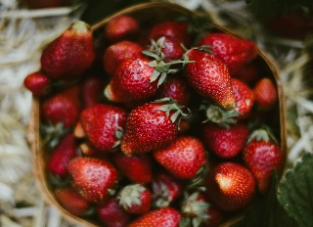
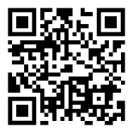
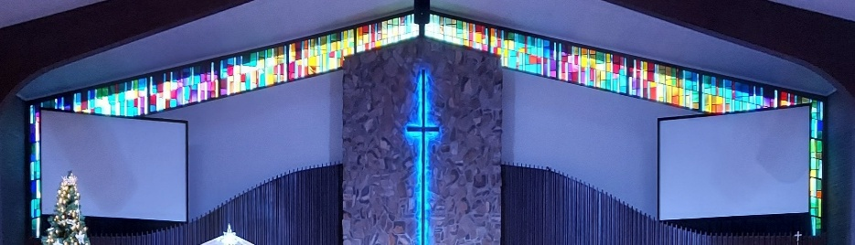
IMMANUEL LUTHERAN CHURCH

Rev. Dr. Douglas A. Krengel, Sole Pastor

Please contact Pastor Krengel for any Pastoral needs. If you need to make an appointment with Pastor Krengel - You are invited to call him on his cell phone or send him an email.

Pastor Krengel’s Cell Phone: 832-257-5437 email: krengeld@gmail.com
Church Office Email: ilc@immanuelbridgman.org Website: www.immanuelbridgman.org

Sunday Services: Traditional 8:30 am, Praise 10:45 am
Worship Services are Streamed Live on Facebook - Immanuel Lutheran Church Bridgman

Sunday Adult Bible Study 9:30 am – ROOM 6
9650 N. Church St., Bridgman, MI 49106 269-465-6031 Church Office
Church Office Hours are 8:00 am – 4:00 pm

Immanuel’s Mission Statement
Immanuel exists to connect all people to Jesus Christ, who embraces all people in His grace, so that we can serve all people in love and discover a hope that heals.
The Third Sunday after Pentecost
June14, 2026
AS WE GATHER: Thanks be to God for 130 years of service to the risen and reigning Jesus Christ here at Immanuel Evangelical Lutheran Church. One hundred and thirty years ago, a small group of laymen reached out to the Lutheran Church – Missouri Synod with a request. Their request was to begin a new congregation in Bridgman. The LCMS responded affirmatively and then sent a student pastor, or vicar, to support the work initiated by the founding fathers of Immanuel Lutheran Church. God blessed and 130 years later Immanuel Lutheran Church continues to present the saving Gospel of Jesus Christ. Thanks be to God!
Today’s Hymns: LSB 790, 801, 805
Today’s Scriptures: Exodus 19:2-8, Romans 5:6-15, Matthew 9:35 – 10:8
Prayers of the Church for Today

Barb Ackerman starting her treatments this week in Chicago
Irwin (Irv) Poschke

Healing Needs for the Month – Please update the office with any changes.

Harriet Fester, Terry Graves, Sharon Korcek, Denny Lawrenz, Norma Linn, Dorothy Ott, Renata Ottusch, Cheryl Petty, Margaret Poschke, Dolly Schmaltz, Tom Ulmer, Beth Vigansky

Immanuel’s website
Welcome Guests! Thank you for spending your time in worship with us! Please take some time to share your contact information by signing the guest book in the narthex.
CHURCH NEWS

The Strawberry Social Today following the service in the Life Center
Let’s Celebrate Immanuel’s 130th Anniversary!

Flowers on the Altar today are in memory of Rich Vonk from Sherry and Family.

SUNDAY ADULT BIBLE STUDY WILL BE IN ROOM 6 FOR THE SUMMER! We will be studying Genesis.

This Saturday - Stand for Life Walk – We will be holding our Walk this June 20, 2026, from 11:30 – 2:00 pm, with a Luncheon & Fellowship afterward. Wipes & Diaper (sizes 5&6 requested). There is a sign-up for desserts for this event! Would need the night before or morning of – Thanks in advance!
Free for ALL in the Gym Drop Off Donations June 23, 24 & 25 from 2:00 – 6:00 pm, The Free for All will start June 26 & 27 from 8:00 – 2:00 pm.
Operation Christmas Child UPDATE –Now that summer is nearly here, Christmas seems far away. But we hope to continue collecting for Operation Christmas Child all year. In June we are gathering sunglasses, puzzles, jump ropes, and yo-yos. The Outreach Committee has an ambitious goal of filling 150 shoeboxes in 2026; every item donated helps! Thank you!
Bridgman Day is July 11, 2026 – We will be out on the front lawn from 12:45 – 2:00 pm. The Parade starts at 2:00pm, we will have a vintage truck in the parade for Immanual, also the Praise Team will be singing in the front yard, and we will have ice cream treats and water for the public. We would love help with setting up tables and chairs. And if anyone has a couple of pop-up tents we could borrow would be great – just let SueEllen Klein or the Church Office know. Thanks!
VBS 2026 – Theme Emerald Crossing – July 13-16 We are looking for volunteers! Please contact Shannon Jones if you are interested. Volunteer sign-ups are in the back of the Narthex, fill out and turn into the Church Office.

VBS 2026 – Registration is Open to sign-up your kiddos and grandkids ages 4-12! Forms are in the back of the Narthex and can be turned into the Church Office.

The Bridges Bags for our Shut ins are available for the summer!

FYI: Planning Committee Members are Pastor Krengel, Kurt Hanke, Al Barker, Devon Girton, SueEllen Klein, Rich Kubsch and Sherri Vonk. If you have any questions, please reach out to one of them.

We are looking for volunteers for a Tween/Teen (11-18 yrs) Bible Study in the Upper Room on Sundays at 9:30 am. We have a curriculum ready and available. Please contact the church office if you are interested.
"Psalms for Summer" will meet NEXT TUESDAY and following Tuesdays this summer at 12:45-2pm on the picnic tables by the children's play area in Harbert Community Park, 13495-13535 Red Arrow Hwy, Sawyer, MI 49125. See you there! Bring a Bible and a friend! Questions? Please contact Pastor Tom Fischer, 248.495.3723.

Last Sunday’s Attendance: 80 - 8:30 am, 49 - 10:45 am
Sunday Bible Study – 14
Thursday Bible Study – 7

Finance News

June 7, 2026, offerings and donations:
Offering Envelopes: $8896.00 Year to date: $158,779.00

Thank You for your Contributions!
Electronic Giving is Available on Immanuel’s Website on the Main Page.

www.immanuelbridgman.org

