
May 31, 2026


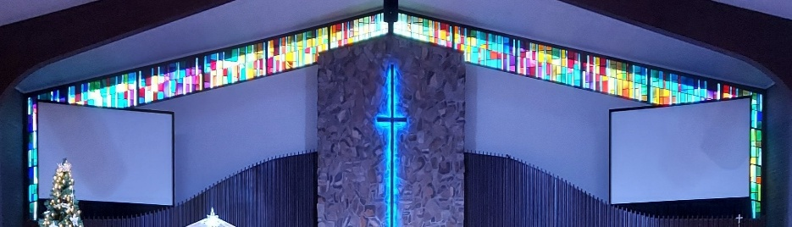
IMMANUEL LUTHERAN CHURCH

Rev. Dr. Douglas A. Krengel, Sole Pastor

Please contact Pastor Krengel for any Pastoral needs. If you need to make an appointment with Pastor Krengel - You are invited to call him on his cell phone or send him an email.

Pastor Krengel’s Cell Phone: 832-257-5437 email: krengeld@gmail.com
Church Office Email: ilc@immanuelbridgman.org Website: www.immanuelbridgman.org

Sunday Services: Traditional 8:30 am, Praise 10:45 am
Worship Services are Streamed Live on Facebook - Immanuel Lutheran Church Bridgman

Sunday Adult Bible Study 9:30 am, “The Rock” Sunday School restarts in September
9650 N. Church St., Bridgman, MI 49106 269-465-6031 Church Office
Church Office Hours are 8:00 am – 4:00 pm

Immanuel’s Mission Statement
Immanuel exists to connect all people to Jesus Christ, who embraces all people in His grace, so that we can serve all people in love and discover a hope that heals.
The Holy Trinity
May 31, 2026
The Holy Trinity – “The non-festival half of the Church Year, that is the Time of the Church, begins following the Feast of the Holy Trinity…. [this season] is also know in some circles as “Ordinary Time.” This semester of the Church Year has been described as “‘the Green Meadow’ because of the green paraments and vestments that are used for the Sundays throughout the Time of the Church.” Today, being the last Sunday before entering Ordinary Time, and today being the Feast of the Holy Trinity, we focus on the Bible’s teaching that just one God exists and yet there are three persons. This morning we will especially focus on the worship of Jesus which the disciples engaged in after Christ’s resurrection and before His ascension a worship that was simultaneously Christ-centered and Trinitarian as is our worship yet today.
Today’s Hymns: LSB 901, 822, 785, 507 vs4, 504, 506, 940
Today’s Scriptures: Genesis 1:1-2:4a; Acts 2:14a, 22-36; Isaiah 6:3b, Matthew 28:16-20
Prayers of the Church for Today

The Family and Friends of Edna Holt
Cheryl Petty, Dorothy Ott, Renata Ottusch
Jeannie Dehring, Ariel Womeldorf

Healing Needs for the Month – Please update the office with any changes.

Barb Ackerman, Harriet Fester, Terry Graves, Sharon Korcek, Denny Lawrenz, Norma Linn, Irwin & Margaret Poschke, Dolly Schmaltz, Tom Ulmer, Beth Vigansky

Shut In Visitations for the Month of May: Visited and communed were Connie Ott, Donna Mach, Donna Springs, Edith Weed, Edna Holt, Harry Rock, Elizabeth Rock, Harriet Fester, Irv & Margaret Poschke, Dorothy Ott, Dorothea Crocker, Denny & Deb Lawrenz, Terry Swedenberg, Lynn & Dollie Schmaltz, Bill Gast, Lorraine & Dillon Jasper, Joanne Argue, Richard & Karen Gorske, Dave Arndt, Terry Graves, Anne Marie Mojsiejenko. Twenty-seven visits were made by the visitation team (Pastor Krengel, Betty Korcek, Paul & Deb Jaeger, Kathy Mammal, & Larry Smith.)

Immanuel’s website
Welcome Guests! Thank you for spending your time in worship with us! Please take some time to share your contact information by signing the guest book in the narthex.
CHURCH NEWS

NOTE: June 14, 2026 will be Immanuel’s 130th Anniversary, in honor of it we will be having a Unity Service at 10:00 AM with a Strawberry Social in the Life Center hosted by LWML!!

From Anne Marie Mojsiejenko: Thank you to Rev. Douglas A. Krengel for the many visits during Waldemar’s recent month long hospital stay. Your prayers were comforting and greatly appreciated. The inspiring message at his funeral was very personal and I felt the peace of God comforting me.

Calling ALL Graduates!! If you are or know a recent graduate – send the Church Office a picture so we can celebrate their accomplishments! Send a picture to ilc@immanuelbridgman.org or text Amie at 269-277-2965. before June 5.

Sumer Handbell Practice starts in June, Monday night’s 6.30-7-30pm Beginning ringers welcome!

VBS 2026 – Theme Emerald Crossing – July 13-16 We are looking for volunteers! Please contact Shannon Jones if you are interested.

FYI: Planning Committee Members are: Pastor Krengel, Kurt Hanke, Al Barker, Devon Girton, SueEllen Klein, Rich Kubsch and Sherri Vonk. If you have any questions, please reach out to one of them.

Operation Christmas Child UPDATE –During the month of May, please take a moment to write a short note to include in a shoebox. A simple note makes the gift more personal for the child receiving the shoebox. There are cards to use by the decorated OCC box in the back of the church, or you can use your own cards. Just return any completed cards (no envelopes needed) to the OCC box. Thank you!

Stand for Life Walk – We will be holding our Walk this June 20, 2026, from 11:30 – 2:00 pm, with a Luncheon & Fellowship afterward. Wipes & Diaper (sizes 5&6 requested).
Free for ALL in the Gym June 26 & 27 from 8:00 – 2:00 pm.
"Psalms for the Summer" at the River Valley Sr Center at 13321 Red Arrow Hwy (1 mile south of Sawyer Rd), Harbert, MI 4911 on Tuesdays, 1:00 PM – 1:50 PM from June 2- August 25. For further information, please contact Pastor Fischer at pastorgolf@gmail.com or 248.495.3723.
Wouldn’t you like to be in a parade vs. watching it?? Outreach is looking for an individual who has a vintage car/truck to drive in the Bridgman Day Parade on July 11, the parade starts at 2:00 pm (line-up will be earlier) we are looking to have a banner or poster to advertise Immanuel’s upcoming VBS the following week. If you are interested, please talk to Sue Ellen Klein, Betty Korcek, Liz Hettig.

We are looking for volunteers for a Tween/Teen (11-18 yrs) Bible Study in the Upper Room on Sundays at 9:30 am. We have a curriculum ready and available. Please contact the church office if you are interested.
Please Note: The receptacles at the front of the church are only for the communion cups only, no trash please!

Last Sunday’s Attendance: 61 - 8:30 am, 44 - 10:45 am
Sunday Bible Study – 16
Thursday Bible Study – 8

Finance News

May 24, 2026, offerings and donations:
Offering Envelopes: $2,774.00 Year to date: $140,386.00

