August 30, 2026
Ephesians 4:20–24 ²⁰But that is not the way you learned Christ!— ²¹assuming that you have heard about him and were taught in him, as the truth is in Jesus, ²²to put off your old self, which belongs to your former manner of life and is corrupt through deceitful desires, ²³and to be renewed in the spirit of your minds, ²⁴and to put on the new self, created after the likeness of God in true righteousness and holiness.

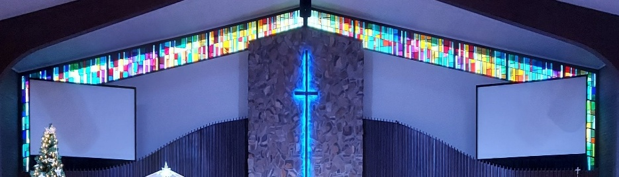


IMMANUEL LUTHERAN CHURCH

Immanuel’s website
Rev. Dr. Douglas A. Krengel, Sole Pastor

Please contact Pastor Krengel for any Pastoral needs. If you would like to make an appointment with Pastor Krengel - You are invited to call him on his cell phone or send him an email or contact the church office.

Pastor Krengel’s Cell Phone: 832-257-5437 email: krengeld@gmail.com
Church Office Email: ilc@immanuelbridgman.org Website: www.immanuelbridgman.org (recently updated)

Sunday Services: Traditional 8:30 am, Praise 10:45 am
Worship Services are Streamed Live on Facebook - Immanuel Lutheran Church Bridgman
Sunday Adult Bible Study 9:30 am – ROOM 6 Studying Genisis 2

Sunday School “The Rock” 9:30 – 10:30 Starts back up on September 20, 2026

9650 N. Church St., Bridgman, MI 49106 269-465-6031 Church Office
Church Office Hours: Monday - Friday from 8:00 am – 4:00 pm

Welcome, guests! We have prepared a small gift bag from the back table to share with you.
Please take a moment to sign the guest book in the narthex so we can stay connected.
Thank you for visiting us. We hope to see you again soon!

Immanuel’s Mission Statement
Immanuel exists to connect all people to Jesus Christ, who embraces all people in His grace, so that we can serve all people in love and discover a hope that heals.

The Thirteenth Sunday after Pentecost
August 30, 2026
“Leave behind me, Satan! You are my stumbling block, for you are not setting your mind on the things of God; rather, [you are] setting your mind on the things of men” (Matthew 16:23, Gibbs). What is your mindset? Or, what priorities dominate your thoughts? What is your top priority in life? Are you dedicated to seeing yourself as the one who directs God, as you are so sure that you know what path in life is best in comparison to Jesus of Nazareth? Or do you have a mindset in which the Reign of Heaven is primary? Do you have a mindset in which Jesus’ cross, and his final return on the Last Day in glory with his angels, is that on which your mind is set? This morning, we pray that God the Holy Spirit will work the miracle of saving faith in our hearts as he works through his Means of Grace, his Word and Sacraments, to create in us the minds set on the story of salvation as found in Jesus Christ alone. Amen.

Today’s Hymns: LSB 685, 733, 783 odd vs only, 861, 643, 718
Today’s Scriptures: Jeremiah 15:15–21; Romans 12:9-21; Matthew 16:21–28
8:30 am Lay Reader: Kevin Berk

Prayers of the Church for Today
Greg Eber (Heart Attack), Bob & Donna Griggs (cancer treatment & complications from a fall) friends of the Dehrings, Caleb Harrington (12 yr old, ITP – Bleeding disorder), All New Troy HS Class of 1966 buddies who are dealing with health issues, loss, etc. – the Dehrings. Please pray for the ECDC Preschool to fill up for the start of the school year.

Healing Needs for the Month – Please update the office with any changes.
Barb Ackerman, Dorthea Crocker, Harriet Fester, Jere Dehring, Terry Graves, Irene High – Stage 4 Stomach (cousins of Richard & Debbie Ruff), Sharon Korcek, Denny Lawrenz, Manfred Moneta, Dorothy Ott, Renata Ottusch, LeeAnn Plukas– friend of Paul & Deb Jaeger, Irwin (Irv) Poschke and Margaret Poschke, Beth Vigansky Ciuzio

CHURCH NEWS

Please note: Pastor Krengel is taking a “Staycation” for the month of August. He will be here on Sunday. If you have any pastoral needs, please call the office at 269-465-6031.
ANNOUNCEMENT: SPECIAL VOTERS MEETING ON September 6, 2026 AFTER THE 8:30 AM SERVICE.
ECDC has Openings for 3- and 4-year-old Private Pay Preschool and Primary Room Childcare.

Special Thank You to Sara Oldenburg for accompaniment on the violin today at the 8:30 AM service.
Calling all Sunday School teachers and helpers! You are invited to attend a Sunday School Planning Meeting on September 6th, after the second service, in the Sunday School room. Come and help make this an amazing school year!
Operation Christmas Child is collecting school supplies throughout August. Pencils, markers, glue sticks, blunt-tip scissors, pencil sharpeners, rulers – there are lots of items kids need for school! The Outreach Committee thanks you for each and every donation you make as we work to assemble the shoeboxes in the fall.

Prayer Pillow Progress! We need a few volunteers to stuff the pillows and do a bit of hand sewing. Please speak with Kim Schmitz or Elizabeth Emery if you can help.
Lutheran Women’s Missionary League (LWML) is planning its next meeting, an Ice Cream Social, for September 8, 2026, at 6:30 p.m. This will be a Reorganization/Planning Meeting. LWML Sunday is the 1st Sunday in October.
Our Youngish Adult Bible Study will be September 9th at 5:30 p.m. at Trinity, Sawyer. We are planning to have light snacks as we continue a Bible Study series on "God's Story." Our study for the 9th will focus on submitting to the Lord's Will for our lives. We would love to have youngish adults (like 20s/30s, but no set limits) from our circuit congregations join us. If you have anyone who is interested, please have them text me at (989)996-5353.
80th LLL Men’s Retreat “Live To Tell About It: – September 10-13, 2026 at Camp Arcadia. Cost $310/pp. See the bulletin board for more information or go to www.camp-arcadia.com/register

Patriotic Service is scheduled for September 13, 2026. Sign-ups for food and attendance are in the Narthex!

Sunday School will resume on September 20th from 9:30-10:30. All ages welcome!
Congregational Planning Retreat, Saturday, September 26, from 9 AM to 1 PM. Copies of the Draft Constitution are in the back of the Narthex; please grab one to review prior to the retreat. See the church office if you need a copy.

Lutheran Singles Weekend – Friday, October 9-11, 2026 at Advent Evangelical Lutheran Church, Zionsville, IN. See the Bulletin Board outside the Church Office for more Details.

Please Note the Next Voter’s Meeting is Sunday, October 25, 2026 after Church. Board Reports must be submitted to the Church Office by October 5, 2026, to allow time for the packets to be assembled and made available to the congregation on October 11, 2026. Now is the time to consider joining a board/team: Administration, Altar Guild, ECDC, Education (Sunday School), Elders, Fellowship, Finance, LWML, Outreach, Safety, Trustees, Worship. All members of Immanuel Lutheran Church are welcome to join; contact the Church Office for more information!

Last Sunday’s Attendance: 67 - 8:30; 52 - 10:45 am
Adult Bible Study - 17
Online: 10 views
Thursday Bible Study -

FINANCE UPDATE
August 23, 2026, offerings and donations:
Offering Envelopes: $3,606.00 Year to date: $226,034.00

Thank You for your Contributions!
Electronic Giving is Available on Immanuel’s Website on the Main Page.
www.immanuelbridgman.org

