August 16, 2026
1 Thessalonians 5:16–18 ¹⁶Rejoice always, ¹⁷pray without ceasing, ¹⁸give thanks in all circumstances; for this is the will of God in Christ Jesus for you.

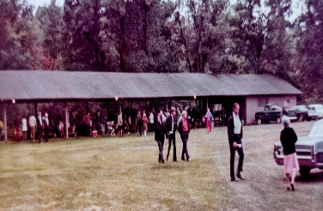
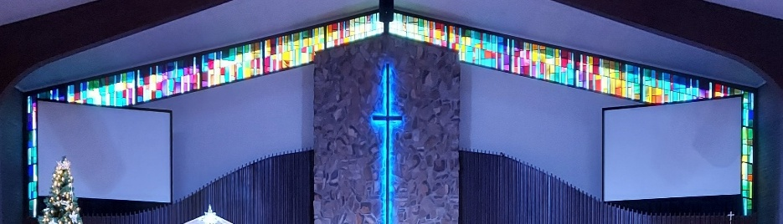

IMMANUEL LUTHERAN CHURCH

Immanuel’s Mission Statement
Immanuel exists to connect all people to Jesus Christ, who embraces all people in His grace, so that we can serve all people in love and discover a hope that heals.
The Ninth Sunday after Pentecost
August 16, 2026
Coach Bill Walsh, the coach of the San Franscico 49ers NFL championship football team defined his team’s culture to consist of the following elements: alignment, communication, ownership, vision and values, connection, and accountability. All of this would also apply to the formation of a culture in a Christian congregation like Immanuel Lutheran Church and Preschool. Unlike a secular organizational agency, the culture of a local church is to consist of a culture of prayer. This morning the prophet Isaiah reveals to us God’s desire for his house to be “a house of prayer for all peoples” (Isaiah 56:7, ESV). May the Holy Spirit bless our church home and gift us with a culture of prayer. Amen.
Today’s Hymns: LSB 901, 770, 571, 831, 832
Today’s Scriptures: Isaiah 56:1, 6-8; Romans 11:1–2a, 13-15, 28-32; Matthew 15:21–28
Lay Reader: Ilene Nemitz
Prayers of the Church for Today

Prayers of Thanks to the Youth Group from Our Savior Lutheran Church in Chelsea, MI – they did many service projects for some of our Seniors along with some cleaning in the Church and the Gym!!

I would like to sincerely thank everyone for the many cards, messages, and expressions of sympathy received after the loss of my husband. Your kindness and support have been a great comfort to me and my family.
-- Sally Burgess

Rev. Dr. Douglas A. Krengel, Sole Pastor

Please contact Pastor Krengel for any Pastoral needs. If you would like to make an appointment with Pastor Krengel - You are invited to call him on his cell phone or send him an email or contact the church office.

Pastor Krengel’s Cell Phone: 832-257-5437 email: krengeld@gmail.com
Church Office Email: ilc@immanuelbridgman.org Website: www.immanuelbridgman.org (recently updated)

Sunday Services: Traditional 8:30 am, Praise 10:45 am
Worship Services are Streamed Live on Facebook - Immanuel Lutheran Church Bridgman
Sunday Adult Bible Study 9:30 am – ROOM 6 Studying Genisis 2

Sunday School “The Rock” 9:30 – 10:30 Starts back up on September 20, 2026

9650 N. Church St., Bridgman, MI 49106 269-465-6031 Church Office
Church Office Hours: Monday - Friday from 8:00 am – 4:00 pm

Immanuel’s website
Welcome, guests! We have prepared a small gift bag from the back table to share with you.
Please take a moment to sign the guest book in the narthex so we can stay connected.
Thank you for visiting us. We hope to see you again soon!

Healing Needs for the Month – Please update the office with any changes.
Barb Ackerman, Dorthea Crocker, Harriet Fester, Jere Dehring, Terry Graves, Irene High – Stage 4 Stomach (cousins of Richard & Debbie Ruff), Sharon Korcek, Denny Lawrenz, Manfred Moneta , Dorothy Ott, Renata Ottusch, Cheryl Petty, LeeAnn Plukas for healing has internal bleeding – friend of the Paul & Deb Jaeger,
Irwin (Irv) Poschke and Margaret Poschke, Beth Vigansky Ciuzio

CHURCH NEWS

Please Note: Pastor Krengel is taking a “Staycation” for the month of August, he will be here on Sunday for the services, if you have any pastoral needs please call the office 269-465-6031.
A special note of thanks to flautist Brie Schmitz for her beautiful contribution to this morning's 8:30 service.

Operation Christmas Child is collecting school supplies during the month of August. Pencils, markers, glue sticks, blunt-tip scissors, pencil sharpeners, rulers – there’s lots of items kids need for school! This is the time of year these things are on sale at local stores, so it’s a great month to shop. The Outreach Committee thanks you for each and every donation you make as we move towards assembling the shoeboxes in the fall.

News Flash! Some of Immanuel's quilts may be on their way to Spokane, Washington. Lutheran World Relief is sending quilts to victims of the terrible wildfires, providing warmth and comfort for people who have lost their homes. What a blessing that we can help! The next quilting morning here at Immanuel is Friday, August 28 at 9:00am. Please come and join us; no sewing skills needed!
Calling All Sheep from VBS! VBS was so much fun this summer that we are having a reunion to get the flock back together again! August 29th from 1:00 -3:00pm the ‘sheep’ are invited to the Life Center for a get-together of crafts, games, and lessons. New ‘sheep’ ages 4 -10 are also invited to join the flock as we all follow our Good Shephard! Please call the church office (465 – 6031) to RSVP or if you have questions.
Lutheran Women’s Missionary League (LWML) – Is planning its next meeting an Ice Cream Social for September 8, 2026, at 6:30 pm this will be a Reorganization/Planning Meeting. LWML Sunday is the 1st Sunday in October.
80th LLL Men’s Retreat “Live To Tell About It: – September 10-13, 2026 at Camp Arcadia Cost $310/pp. See the bulletin board for more information or go to www.camp-arcadia.com/register

Patriotic Service is scheduled for September 13, 2026.

ECDC has Openings for 3 & 4 yr old Private Pay Preschool and Primary Room Childcare ages 3&4.

GSRP at Immanuel has 2 Openings for the Fall starting September 14, 2026.

Sunday School will start up again on September 20th from 9:30-10:30. All ages welcome!
Congregational Planning Retreat, Saturday, September 26, from 9 AM to 1 PM. Copies of the Draft Constitution are in the back of the Narthex, please grab one to review prior to the retreat. See the church office if you need a copy.
FYI: Planning Committee Members are Pastor Krengel, Kurt Hanke, Al Barker, Devon Girton, SueEllen Klein, Rich Kubsch and Sherri Vonk. If you have any questions, please reach out to one
of them.

Please Note the Next Voter’s Meeting is Sunday, October 25, 2026 after Church. Board Reports will need to be turned into the Church Office by October 5, 2026 to allow time for the packets to be assembled and available to the congregation on October 11, 2026.

Last Sunday’s Attendance Church Picnic: 115 - 10:00 am
Thursday Bible Study - 6

Finance News

August 9, 2026, offerings and donations:
Offering Envelopes: $4,431.00 Year to date: $215,549.00

Thank You for your Contributions!
Electronic Giving is Available on Immanuel’s Website on the Main Page.
www.immanuelbridgman.org

Volunteer Opportunities:

Looking for Sunday School Lead Teachers for Littles & Tweens, Teens to start in September if you have an interest and would like to be considered, please see the Administration Board (Larry Smith) ASAP!

Help at LCMS Berrien County Youth Fair Booth - We need your help at the Youth Fair Information Booth next week! We've got tons of materials and prizes to share, and it's a fantastic opportunity for your church (and school) to connect with the community and reach new people. Sign up at trinityberrien.org – we especially need you on Monday and Saturday! I have a free gate pass for you if you let me know this week.

Tech Volunteers are needed for both services. We need someone willing to learn how to do the streaming for the second service and we are looking for people to run the slides and the sound board for both services. If anyone has interest please contact Deb Jaeger.

Bridges Bags are ready to check out and deliver in the back of the Narthex!

Are you a good reader? Outspoken? Attend the 8:30 am Service? We are looking to grow our lay reader pool.
Why not jump in? If interested just stop in or call the Church Office!!

The Voter’s Meeting coming up in October, now is the time to consider joining a board / team:
Administration, Altar Guild, ECDC, Education (Sunday School), Elders, Fellowship, Finance, LWML, Outreach, Safety, Trustees, Worship. All members of Immanuel Lutheran Church are welcome to join, contact the Church Office for more information!

Wanted: A few volunteers to sew 9” X 9” polar fleece prayer pillows for our children in ECDC. These cuddly pillows will hold a book written by Barb Ackerman that teaches children how to pray to their Heavenly Father. The fabric is already cut – we are just looking for some helpers to do the sewing. Speak with Liz Emery or Kim Schmitz if you have questions.

Galatians 6:9–10
⁹And let us not grow weary of doing good, for in due season we will reap, if we do not give up.
¹⁰So then, as we have opportunity, let us do good to everyone, and especially to those who are of the household of faith.

