October 25, 2026
James 2:19
¹⁹You believe that God is one; you do well. Even the demons believe—and shudder!

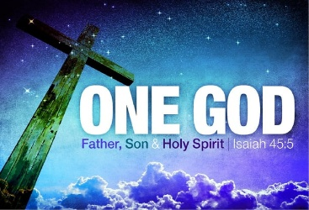
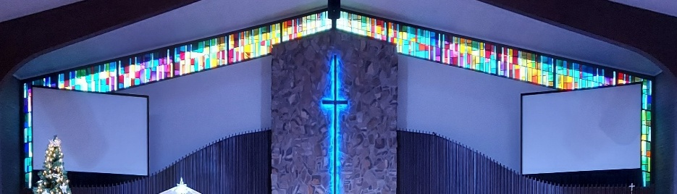

IMMANUEL LUTHERAN CHURCH

Immanuel’s Mission Statement
Immanuel exists to connect all people to Jesus Christ, who embraces all people in His grace, so that we can serve all people in love and discover a hope that heals.

As We Gather
One of life's joys is socializing with friends. The children and youth returned to school two months ago. By now their friend groups should be well established. The friends people make in their formative years are sometimes a person’s best friends. When individuals attend their high school reunion celebrations, reconnecting with friends is usually one reason they attend. In these last days, some observe that there is a friendship drought. This morning we are invited by Jesus to be best friends, as Jesus is called a “friend of sinners” (Matthew 11:19). In addition, we will consider Martin Luther’s social circle. Luther’s friends cared for him while he faced challenge after challenge. While Martin Luther’s physical life was saved by his friends, Luther’s best friend was Jesus Christ. May we all rejoice this morning with our best friend, Jesus Christ. Amen.
Reformation Day
October 18, 2026

Today’s Hymns: LSB 656, 556, 578
Today’s Scriptures: Revelation 14:6–7, Romans 3:19–28, John 8:31–36
8:30 am Lay Reader: Kevin Berk

Prayers of the Church for Today

Family & friends of Edie Paul – Funeral October 28, 2026, Visitation 10:00 am, Service at 11:00 am, Luncheon immediately after in the Life Center
Karen Glosson (cancer) friend of Pastor Krengel,
Louis Kopp (Grandfather of Shannah Smith and GGpa to Faith, Colt, Kinsley),
Carol Moneta,

Immanuel’s website
Rev. Dr. Douglas A. Krengel, Sole Pastor

Please contact Pastor Krengel for any Pastoral needs.

Pastor Krengel’s Cell Phone: 832-257-5437 Email: krengeld@gmail.com
Church Office Email: ilc@immanuelbridgman.org Website: www.immanuelbridgman.org

Sunday Services: Traditional 8:30 am, Praise 10:45 am
Worship Services are Streamed Live on Facebook - Immanuel Lutheran Church Bridgman
Sunday Adult Bible Study 9:30 am – ROOM 6 Studying Islam

Sunday School “The Rock” 9:30 – 10:30 am

9650 N. Church St., Bridgman, MI 49106 269-465-6031 Church Office
Church Office Hours: Monday - Friday from 8:00 am – 4:00 pm

Bible Study Opportunities: Monday & Wednesday @ 10:00 am, Breakfast with Jesus at Rochefort’s in Bridgman on Thursdays at 8:00 am. Evening Adult Bible Study at Trinity Sawyer Wednesday @ 5:30 pm.

Welcome, guests! We have prepared a small gift bag from the back table to share with you.
Please take a moment to sign the guest book in the narthex so we can stay connected.
Thank you for visiting us. We hope to see you again soon!

Prayers for the Month– Please update the office with any changes.
Jim Baracin (fall) - Karen Oldenburg’s Brother, Dorthea Crocker, Kathi Sharp (cancer) – the Dehrings. Harriet Fester, Irene High (cancer), Sharon Korcek, Dorothy Ott, Renate Ottusch, LeeAnn Plukas (friend of the Jaegers), Irwin (Irv) Poschke, Terry Swedenberg & Gustuv Springs (brother & husband of Donna Springs).

CHURCH NEWS

Thank you to Marion Winter for playing for worship today. We are grateful for her musical gift and service.

Voters’ Meeting today after the Service. We will also be having a Pastor Appreciation luncheon HOSTED BY FELLOWSHIP.

Fall Ball at Trinity Lutheran Sawyer: Friday, October 30, 2026 • 4:00-6:00 p.m. Bring the whole family for a fun-filled evening of church-friendly costumes, crafts, games, dancing, and fall treats. Enjoy a caramel apple bar, baked goods, and more while children participate in a variety of fall-themed activities. Free and open to the public. Donations are welcome.
Don’t forget to CHANGE YOUR CLOCKS on Saturday, October 31st … fall back one hour.
The Circuit Reformation Service, November 1, 3:30 p.m., Immanuel Lutheran Church, Bridgman. Dinner to follow hosted by Fellowship.

A new EVENING Bible study will be starting on November 10, 2026, on Tuesdays at 6:00 p.m., led by Oscar Delgado and Larry Smith. If you are interested, please sign up in the back of the Narthex or contact the church office. The study will be on the book “I Will - The Nine Traits of the Outwardly Focused Christian” by Thom S. Rainer.

Operation Christmas Child's final month for donations is here! We are collecting dolls, trucks/cars, puzzles, card games - fun things that kids anywhere love to receive. AND please save the date - November 14th - for a PEW Party. You are invited to help Pack Operation Christmas Child shoeboxes, Eat a dinner together, and Watch a family-friendly movie in the Life Center. The fun starts at 5:00 pm. Sign Up sheets are in the Narthex!

The Ladies Circle at St. Paul Cassopolis is holding their Annual Holiday Bazaar on November 14, 2026.

Thrivent’s Giving Tuesday is December 1, 2026!

Volunteers Needed! Please consider hosting an Advent Midweek Luncheon or Dinner on December 2, 9, or 16. Meals are served at 1:15 p.m. and 5:00 p.m. Sign-up sheets are available in the narthex.

Support our Early Child Care Center by purchasing items from their Amazon Wish List:
https://www.amazon.com/hz/wishlist/ls/YR8M992K16L3?ref=cm_sw_em_r_un_un_TQcleNEgT9sAb

Visitation Scheduling has been turned over to the Church Office, so if anyone needs to be added or removed, please call the office.

Our ambassador bears will be in hibernation for the winter months, and we'll be doing the same! With the cold weather coming, we want to protect our Christian friends from the elements and sickness. We will resume in the spring when the bears are out of hibernation! After delivery of a special Holiday goodie bag, we will still send letters and cards from the children and check in with phone calls. In the meantime, the Bridges Program will be restructured to better meet our congregation's needs and abilities. Thank you to all congregation members who have generously given their time to deliver goodies from our Sunday School and School Age Day Care children to our elder homebound members!

Funeral Service Planning Forms are available in the back of the Narthex. This simple form allows you to record your funeral service wishes and preferences. Once completed, you may return the form to the church office, where it will be kept in your member file for future reference.

Last Sunday’s Attendance: 73 - 8:30 am; 47 - 10:45 am
Bible Studies: 15 (Sun), 9 (Mon), 6 (Wed), 7 (Thurs)
Online views: 16

FINANCE UPDATE

October 18, 2026, offerings and donations:
Offering Envelopes: $11,410.00 Year to date: $290,250.00
Sacristy Repairs Raised: $20,935.00

Thank You for your Contributions!
Electronic Giving is Available on Immanuel’s Website on the Main Page.
www.immanuelbridgman.org

