November 1, 2026
Revelation 14:13
¹³And I heard a voice from heaven saying, “Write this: Blessed are the dead who die in the Lord from now on.” “Blessed indeed,” says the Spirit, “that they may rest from their labors, for their deeds follow them!”

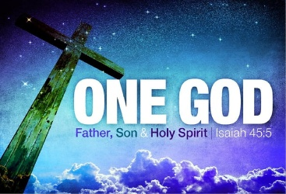
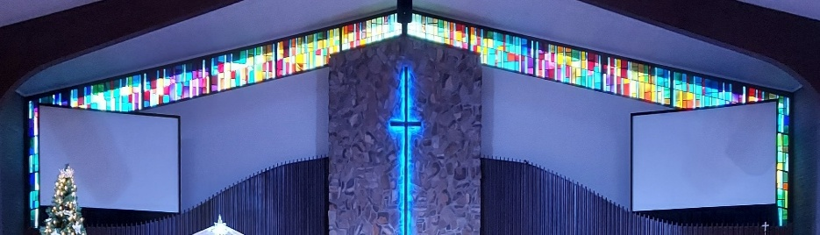

IMMANUEL LUTHERAN CHURCH

Immanuel’s Mission Statement
Immanuel exists to connect all people to Jesus Christ, who embraces all people in His grace, so that we can serve all people in love and discover a hope that heals.

As We Gather
As we enter the month of November, we also enter the end of the church year. Sunday, November 22, is the last Sunday of the church year. November 29 is the first Sunday in Advent and the beginning of the new church year. As the church year comes to an end, our thoughts are directed to the end of time when Christ will return in glory. On this Sunday, All Saints' Day, we remember those who now see God. This morning we will prepare our souls to enter eternal life by confessing our sins to God and by receiving holy absolution, by listening to the inspired word of God, by confessing our faith, by praying, by receiving Holy Communion, and by receiving the risen Christ’s blessing. May the Holy Spirit bring us to find our hope in no other source than Jesus Christ, crucified, risen, and reigning. Amen.
All Saints Day
November 1, 2026

Today’s Hymns: LSB 672, 676, 677 vs 1-3, 677 vs 4-6, 677 vs 7-8, 673, 672, 670
Today’s Scriptures: Revelation 7:2–17, 1 John 3:1–3, Matthew 5:1–12
8:30 am Lay Reader:

Prayers of the Church for Today

Family & friends of Edie Paul

Karen Glosson (cancer), friend of Pastor Krengel, Kathy Mammal, Carol Moneta

Prayers for the Month– Please update the office with any changes.
Jim Baracin (fall) - Karen Oldenburg’s Brother, Dorthea Crocker, Louis Kopp, Kathi Sharp (cancer) – the Dehrings. Harriet Fester, Irene High (cancer), Sharon Korcek, Dorothy Ott, Renate Ottusch, LeeAnn Plukas (friend of the Jaegers), Irwin (Irv) Poschke, Terry Swedenberg & Gustav Springs (brother & husband of Donna Springs).

Immanuel’s website
Rev. Dr. Douglas A. Krengel, Sole Pastor

Please contact Pastor Krengel for any Pastoral needs.

Pastor Krengel’s Cell Phone: 832-257-5437 Email: krengeld@gmail.com
Church Office Email: ilc@immanuelbridgman.org Website: www.immanuelbridgman.org

Sunday Services: Traditional 8:30 am, Praise 10:45 am
Worship Services are Streamed Live on Facebook - Immanuel Lutheran Church Bridgman
Sunday Adult Bible Study 9:30 am – ROOM 6 Studying Islam

Sunday School “The Rock” 9:30 – 10:30 am

9650 N. Church St., Bridgman, MI 49106 269-465-6031 Church Office
Church Office Hours: Monday - Friday from 8:00 am – 4:00 pm

Bible Study Opportunities: Monday & Wednesday @ 10:00 am, Breakfast with Jesus at Rochefort’s in Bridgman on Thursdays at 8:00 am. Evening Adult Bible Study at Trinity Sawyer Wednesday @ 5:30 pm.

Welcome, guests! We have prepared a small gift bag from the back table to share with you.
Please take a moment to sign the guest book in the narthex so we can stay connected.
Thank you for visiting us. We hope to see you again soon!

CHURCH NEWS

TODAY: Circuit Reformation Service, November 1, 3:30 p.m., Immanuel Lutheran Church, Bridgman. Dinner to follow, hosted by Fellowship.

Church Directory Photos – Amie will be available 9:30–10:30 am on Sundays and throughout the week during regular church hours to take photos for our church directory as members are available. Please note that these photos will not be professional studio photos, so there is no cost and nothing to purchase. I would be happy to email your photo(s) to you so that you may print them or use them however you wish at your own convenience. If you have a photo you would like to use, please email it to ilc@immanuelbridgman.org.

A new EVENING Bible study will be starting on November 10, 2026, on Tuesdays at 6:00 p.m., led by Oscar Delgado and Larry Smith. If you are interested, please sign up in the back of the Narthex or contact the church office. The study will be on the book “I Will - The Nine Traits of the Outwardly Focused Christian” by Thom S. Rainer.

Christmas? Already? It’s almost time to pack and send Operation Christmas Child shoeboxes! Thanks for the many donations throughout the year to help Immanuel share the love of Jesus with children. Please come to the packing party on November 14th and help fill the shoeboxes. After packing, enjoy dinner and a family-friendly movie together. It all starts at 5:00 pm. The sign-up sheet is in the back of the sanctuary; this helps us plan for dinner. If you prefer to pack your own shoebox – great! Empty boxes and lists of suggested items are in the back of the sanctuary. Please have your filled shoebox at Immanuel on Sunday, November 15th.

The Ladies Circle at St. Paul Cassopolis is holding their Annual Holiday Bazaar on November 14, 2026.

We will update the church mailboxes the week of November 9-14. Please check your current mailbox for any of your items.

Please note a Special Voters’ Meeting is Sunday, November 15, 2026, after Church.

Sewing for Missions quilters are meeting next on Friday, November 20, at 9:00 am. Please consider joining us - no sewing skills required, as we assemble and tie the quilts.

Thrivent’s Giving Tuesday is December 1, 2026!

Volunteers Needed! Please consider hosting an Advent Midweek Luncheon or Dinner on December 2, 9, or 16. Meals are served at 1:15 p.m. and 5:00 p.m. Sign-up sheets are available in the narthex.

Support our Early Child Care Center by purchasing items from their Amazon Wish List:
https://www.amazon.com/hz/wishlist/ls/YR8M992K16L3?ref=cm_sw_em_r_un_un_TQcleNEgT9sAb

Visitation Scheduling has been turned over to the Church Office, so if anyone needs to be added or removed, please call the office.

Our ambassador bears will be in hibernation for the winter months, and we'll be doing the same! With the cold weather coming, we want to protect our Christian friends from the elements and sickness. We will resume in the spring when the bears are out of hibernation! After delivery of a special Holiday goodie bag, we will still send letters and cards from the children and check in with phone calls. In the meantime, the Bridges Program will be restructured to better meet our congregation's needs and abilities. Thank you to all congregation members who have generously given their time to deliver goodies from our Sunday School and School Age Day Care children to our elder homebound members!

Last Sunday’s Attendance: 106 - 10:00 am
Bible Studies: 8 (Mon), 8 (Wed), 7 (Thurs)
Online views: 10

FINANCE UPDATE

November 1, 2026, offerings and donations:
Offering Envelopes: $4,180.00 Year to date: $294,430.00

Thank You for your Contributions!
Electronic Giving is Available on Immanuel’s Website on the Main Page.
www.immanuelbridgman.org

