October 11, 2026
1 Thessalonians 5:12–13
¹²We ask you, brothers, to respect those who labor among you and are over you in the Lord and admonish you, ¹³and to esteem them very highly in love because of their work. Be at peace among yourselves.


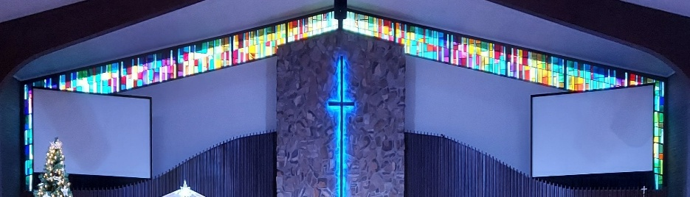

IMMANUEL LUTHERAN CHURCH

Immanuel’s Mission Statement
Immanuel exists to connect all people to Jesus Christ, who embraces all people in His grace, so that we can serve all people in love and discover a hope that heals.

As We Gather
Football season is now in full swing. How do football teams win games? Win championships? They are, literally, goal oriented. Even more so this is the case for the church. How did the early church spiritually mature and numerically grow? Paul gives the answer to the Christians in the city of Philippi: “…I press on toward the goal…” May we as individual Christians, may we as Christian families, and may we as Immanuel Lutheran Church by the power of the Holy Spirit “…press on toward the goal for the upward call of God in Christ Jesus.”
The Nineteenth Sunday after Pentecost
October 11, 2026

Today’s Hymns: LSB 633, 570 vs 1,3,5; 806, 475
Today’s Scriptures: Isaiah 25:6–9, Philippians 4:4–13, Matthew 22:1–14

8:30 am Lay Reader: Nancy Seldomridge

Prayers of the Church for Today
Jim Baracin (fall) - Karen Oldenburg’s Brother, Edie Paul (neck surgery)

Prayers for the Month– Please update the office with any changes.
Barb Ackerman, Dorthea Crocker, Bob & Donna Griggs friends of the Dehrings, Kathi Sharp (cancer) – the Dehrings. Harriet Fester, Terry Graves, Irene High – Stage 4 Stomach cancer, Sharon Korcek, Denny Lawrenz, Dorothy Ott, Renate Ottusch, LeeAnn Plukas – friend of the Jaegers, Irwin (Irv) Poschke, Terry Swedenberg & Gustuv Springs (brother & husband of Donna Springs).

Rev. Dr. Douglas A. Krengel, Sole Pastor

Please contact Pastor Krengel for any Pastoral needs. To make an appointment with Pastor Krengel, call his cell phone, email him, or contact the church office.

Pastor Krengel’s Cell Phone: 832-257-5437 Email: krengeld@gmail.com
Church Office Email: ilc@immanuelbridgman.org Website: www.immanuelbridgman.org

Sunday Services: Traditional 8:30 am, Praise 10:45 am
Worship Services are Streamed Live on Facebook - Immanuel Lutheran Church Bridgman
Sunday Adult Bible Study 9:30 am – ROOM 6 Studying Islam

Sunday School “The Rock” 9:30 – 10:30 am

9650 N. Church St., Bridgman, MI 49106 269-465-6031 Church Office
Church Office Hours: Monday - Friday from 8:00 am – 4:00 pm

Bible Study Opportunities: Monday & Wednesday @ 10:00 am, Breakfast with Jesus at Rochefort’s in Bridgman on Thursdays at 8:00 am. Evening Adult Bible Study at Trinity Sawyer Wednesday @ 5:30 pm.

Immanuel’s website
Welcome, guests! We have prepared a small gift bag from the back table to share with you.
Please take a moment to sign the guest book in the narthex so we can stay connected.
Thank you for visiting us. We hope to see you again soon!

CHURCH NEWS

Pastor Appreciation Day is TODAY. Thank you, Pastor Krengel, for all you do!

Today, is the LWML Fall Rally IS October 11, 2026, at St. Paul Lutheran Church, 305 W. State St., Cassopolis. Registration: 2:00 pm Program: 2:30 p.m. Flyers are in the Narthex for more information.

CANCELLED: The LWML Meeting for Oct. 13th at 6:30 p.m. in the Life Center.

Men’s Network Breakfast at 8:00 am on October 17, 2026.

Annual Chicken Dinner at Trinity Lutheran of Glendora, Wednesday, October 21, 2026. Call Carolyn for Tickets by October 18th at 269-422-1311. Adults $15 / Children (4-10 yrs) $8. See the Flyer on the Bulletin for more Details.

Please note the next Voters’ Meeting is Sunday, October 25, 2026, after Church. Please take a copy of the Voters Meeting Packet in the back of the Narthex for your review.

The Circuit Reformation Service, November 1, 3:30 p.m., Immanuel Lutheran Church, Bridgman -

Operation Christmas Child's final month for donations is here! We are collecting dolls, trucks/cars, puzzles, card games - fun things that kids anywhere love to receive. AND please save the date - November 14th - for a PEW Party. You are invited to help Pack Operation Christmas Child shoeboxes, Eat a dinner together, and Watch a family-friendly movie in the Life Center. The fun starts at 5:00 pm. Hope to see you there!

With the Voters’ Meeting coming up in October, now is the time to consider joining a board/team: Administration, Altar Guild, ECDC, Education (Sunday School), Elders, Fellowship, Finance, LWML, Outreach, Safety, Trustees, Worship. All members of Immanuel Lutheran Church are welcome to join; contact the Church Office for more information!

Bible Studies Immanuel - Evening Adult Bible Study at Trinity Sawyer Wednesday @ 5:30 pm.

SAVE THE DATE FOR THE JR. HIGH GATHERING 2027 August 3-5, 2027 | Frankenmuth

Last Sunday’s Attendance: 74 - 8:30 am; 48 - 10:45 am
Bible Studies: 17 (Sun), 5 (Mon), (Wed), (Thurs)
Online views:

FINANCE UPDATE
October 4, 2026, offerings and donations:
Offering Envelopes: $10,936.00 Year to date: $273,288.00
Sacristy Repairs Raised: $19,700.00

Thank You for your Contributions!
Electronic Giving is Available on Immanuel’s Website on the Main Page.
www.immanuelbridgman.org

