August 23, 2026
Matthew 16:19 ¹⁹I will give you the keys of the kingdom of heaven, and whatever you bind on earth shall be bound in heaven, and whatever you loose on earth shall be loosed in heaven.”


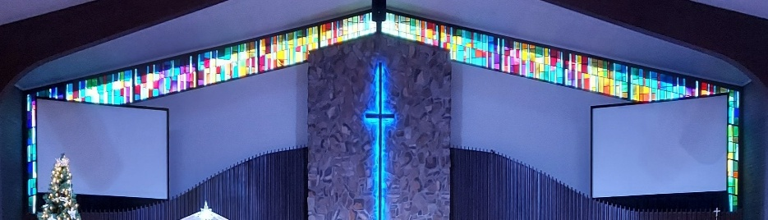
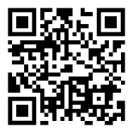
IMMANUEL LUTHERAN CHURCH

Immanuel’s Mission Statement
Immanuel exists to connect all people to Jesus Christ, who embraces all people in His grace, so that we can serve all people in love and discover a hope that heals.
The Thirteenth Sunday after Pentecost
August 23, 2026
In these modern days, physical keys are old news. Today one’s car may be started with a keyless fab. When staying at a hotel, today’s traveler may receive a code on the hotel app. The hotel guest merely swipes his/her smartphone in front of the electronic door and the lock is released. While our lives may include very few locks which require physical keys, Jesus reveals to us this morning that our consciences are still serviced by two spiritual keys: one key to retain sins and one key to absolve sins. In this morning’s Gospel lesson, our Lord Jesus Christ makes it abundantly clear that he has authorized both keys to be placed into the care of the local church. Such was the case in 30 A.D. at the time of Jesus of Nazareth led his disciples around Israel, and such is still the case in these last days. May the Holy Spirit open to us His Word regarding the Power of the Keys and the Office of the Keys. Amen.
Today’s Hymns: LSB 506, 645, 582, 919
Today’s Scriptures: Isaiah 51:1-6; Romans 11:33-12:8; Matthew 16:13–20
8:30 am Lay Readers: Chad Hettig(OT, Epistle, Rdr2), Karen Pedde (Rdr1), Kurt Hanke (Rdr3)
10:45 am Lay Readers: Larry Smith (Rdr1), Colt Smith (Rdr2), JD Girton (Rdr3)

Prayers of the Church for Today
Caleb Harrington (12 yr old, ITP – Bleeding disorder) family of Larry & Amie Smith Family

Healing Needs for the Month – Please update the office with any changes.
Barb Ackerman, Dorthea Crocker, Harriet Fester, Jere Dehring, Terry Graves, Irene High – Stage 4 Stomach (cousins of Richard & Debbie Ruff), Sharon Korcek, Denny Lawrenz, Manfred Moneta , Dorothy Ott, Renata Ottusch, LeeAnn Plukas– friend of the Paul & Deb Jaeger, Irwin (Irv) Poschke and Margaret Poschke, Beth Vigansky Ciuzio

Immanuel’s website
Rev. Dr. Douglas A. Krengel, Sole Pastor

Please contact Pastor Krengel for any Pastoral needs. If you would like to make an appointment with Pastor Krengel - You are invited to call him on his cell phone or send him an email or contact the church office.

Pastor Krengel’s Cell Phone: 832-257-5437 email: krengeld@gmail.com
Church Office Email: ilc@immanuelbridgman.org Website: www.immanuelbridgman.org (recently updated)

Sunday Services: Traditional 8:30 am, Praise 10:45 am
Worship Services are Streamed Live on Facebook - Immanuel Lutheran Church Bridgman
Sunday Adult Bible Study 9:30 am – ROOM 6 Studying Genisis 2

Sunday School “The Rock” 9:30 – 10:30 Starts back up on September 20, 2026

9650 N. Church St., Bridgman, MI 49106 269-465-6031 Church Office
Church Office Hours: Monday - Friday from 8:00 am – 4:00 pm

Welcome, guests! We have prepared a small gift bag from the back table to share with you.
Please take a moment to sign the guest book in the narthex so we can stay connected.
Thank you for visiting us. We hope to see you again soon!

CHURCH NEWS

Please Note: Pastor Krengel is taking a “Staycation” for the month of August, he will be here on Sunday, if you have any pastoral needs please call the office 269-465-6031.
ANNOUNCEMENT: SPECIAL VOTERS MEETING ON September 6, 2026 AFTER THE 8:30 AM SERVICE.
Calling all Sunday School teachers and helpers! You are invited to attend a Sunday School Planning Meeting on September 6th after second service in the Sunday School room. Come and help make this an amazing school year!
Operation Christmas Child is collecting school supplies during the month of August. Pencils, markers, glue sticks, blunt-tip scissors, pencil sharpeners, rulers – there’s lots of items kids need for school! The Outreach Committee thanks you for each and every donation you make as we move towards assembling the shoeboxes in the fall.

News Flash! Some of Immanuel's quilts may be on their way to Spokane, Washington. Lutheran World Relief is sending quilts to victims of the terrible wildfires, providing warmth and comfort for people who have lost their homes. The next quilting morning here at Immanuel is Friday, August 28 at 9:00am. Please come and join us; no sewing skills needed!
Prayer Pillow Progress! We need a few volunteers to stuff the pillows and do a bit of hand sewing. Please speak with Kim Schmitz or Elizabeth Emery if you can help.
Calling All Sheep from VBS! VBS was so much fun this summer that we are having a reunion to get the flock back together again! August 29th from 1:00 -3:00pm the ‘sheep’ are invited to the Life Center for a get-together of crafts, games, and lessons. New ‘sheep’ ages 4 -10 are also invited to join the flock as we all follow our Good Shephard! Please call the church office (465 – 6031) to RSVP or if you have questions.
Lutheran Women’s Missionary League (LWML) – Is planning its next meeting an Ice Cream Social for September 8, 2026, at 6:30 pm this will be a Reorganization/Planning Meeting. LWML Sunday is the 1st Sunday in October.
80th LLL Men’s Retreat “Live To Tell About It: – September 10-13, 2026 at Camp Arcadia Cost $310/pp. See the bulletin board for more information or go to www.camp-arcadia.com/register

Patriotic Service is scheduled for September 13, 2026.

ECDC has Openings for 3 & 4 yr old Private Pay Preschool and Primary Room Childcare ages 3&4.

Sunday School will start up again on September 20th from 9:30-10:30. All ages welcome!
Congregational Planning Retreat, Saturday, September 26, from 9 AM to 1 PM. Copies of the Draft Constitution are in the back of the Narthex, please grab one to review prior to the retreat. See the church office if you need a copy.

Lutheran Singles Weekend – Friday, October 9-11, 2026 at Advent Evangelical Lutheran Church, Zionsville, IN. See the Bulletin Board outside the Church Office for more Details.

Please Note the Next Voter’s Meeting is Sunday, October 25, 2026 after Church. Board Reports will need to be turned into the Church Office by October 5, 2026 to allow time for the packets to be assembled and available to the congregation on October 11, 2026. Now is the time to consider joining a board / team: Administration, Altar Guild, ECDC, Education (Sunday School), Elders, Fellowship, Finance, LWML, Outreach, Safety, Trustees, Worship. All members of Immanuel Lutheran Church are welcome to join, contact the Church Office for more information!

Last Sunday’s Attendance Church Picnic: 69- 8:30; 50 - 10:45 am
Online:
Thursday Bible Study -

FINANCE UPDATE
Church 7 Months 2026 Surplus/(Deficit) ($45,441)
Child Care 7 Months 2026 Surplus/(Deficit) ($63,098)

Thank You for your Contributions!
Electronic Giving is Available on Immanuel’s Website on the Main Page.
www.immanuelbridgman.org

