July 26, 2026
Psalm 23:4 – “Even though I walk through the valley of the shadow of death, I will fear no evil, for you are with me; your rod and your staff they comfort me.”

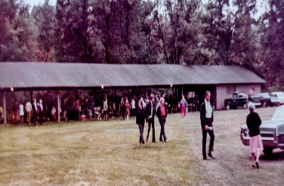
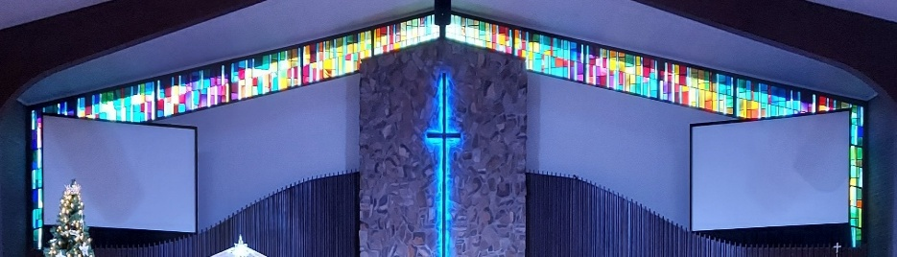

IMMANUEL LUTHERAN CHURCH

Immanuel’s website
Immanuel’s Mission Statement
Immanuel exists to connect all people to Jesus Christ, who embraces all people in His grace, so that we can serve all people in love and discover a hope that heals.
The Ninth Sunday after Pentecost
July 26, 2026
Jesus famously teaches, “where your treasure is, there your heart will be also” (Matthew 6:21), and Jesus knows a treasure when He sees one. Listen to the Readings in worship today. From the days of the Old Testament onward, the Lord has clearly declared how He vastly treasures His people. The Son of God gives up everything to reclaim you as His treasured possession. And it is purely His love for you that gives you true value and limitless worth. Since His treasure is His people, you can be sure His heart remains with His people too, as He visits us here with the priceless goodness of His Word and Sacrament.
Today’s Hymns: LSB 821, 746, 789, 818
Today’s Scriptures: Deuteronomy 7:6–9, Romans 8:28–39, Matthew 13:44–52
Lay Reader: Kevin Berk

Prayers of the Church for Today
Barb Ackerman, Dorthea Crocker, Harriet Fester, Irene High – Stage 4 Stomach cancer & Mike High – Jacob’s Disease on Hospice (cousins of Richard & Debbie Ruff); Manfred Moneta – shoulder surgery, Beth Vigansky Ciuzio

Healing Needs for the Month – Please update the office with any changes.
Terry Graves, Sharon Korcek, Denny Lawrenz, Dorothy Ott, Renata Ottusch, Cheryl Petty,
Irwin (Irv) Poschke and Margaret Poschke
Rev. Dr. Douglas A. Krengel, Sole Pastor

Please contact Pastor Krengel for any Pastoral needs. If you would like to make an appointment with Pastor Krengel - You are invited to call him on his cell phone or send him an email or contact the church office.

Pastor Krengel’s Cell Phone: 832-257-5437 email: krengeld@gmail.com
Church Office Email: ilc@immanuelbridgman.org Website: www.immanuelbridgman.org (recently updated)

Sunday Services: Traditional 8:30 am, Praise 10:45 am
Worship Services are Streamed Live on Facebook - Immanuel Lutheran Church Bridgman
Sunday Adult Bible Study 9:30 am – ROOM 6

9650 N. Church St., Bridgman, MI 49106 269-465-6031 Church Office
Church Office Hours: Monday - Friday from 8:00 am – 4:00 pm

Welcome, guests! We have prepared a small gift bag from the back table to share with you.
Please take a moment to sign the guest book in the narthex so we can stay connected.
Thank you for visiting — we hope to see you again soon!

CHURCH NEWS

Flowers on the altar today are in Honor of Liz Zielke – Happy Birthday! From her family.

It's 'Christmas in July' for Operation Christmas Child! Our donations have fallen off a bit in the past 2 months, so the Outreach Board is praying for lots of items to fill lots of shoeboxes. In July we are collecting fun band-aides, wash clothes, nail clippers & files. The Dollar Store is a great place to find these items very inexpensively. And don't forget the clearance areas at Meijer's or other stores. All donations can be left in the decorated box by the Christmas tree.

Saturday, July 25, 2026 Family Fun Festival at Christ Lutheran Church.

$20 Pew Editions for 20 Years of Lutheran Service Book - Celebrate the 20th anniversary of Lutheran Service Book with this limited-time sale! Now through July 31, the Pew Edition is only $20 and everything else in the LSB family is 20% off. www.cph.org/on-sale/lsb-20th-anniversary-sale

Church Picnic is scheduled for August 9, 2026! Hymn Sing starts at 9:30 am, Unity Service 10:00 am, Fellowship Meal will be served at 11:30 am. Don't forget to sign up if your attending and for the dish you'd like to share. The sign-up sheet is available in the back of the Narthex.

Patriotic Service is scheduled for September 13, 2026.

80th LLL Men’s Retreat “Live To Tell About It: – September 10-13, 2026 at Camp Arcadia Cost $310/pp. See the bulletin board for more information or go to www.camp-arcadia.com/register

Volunteer Opportunities:

The only thing better than eating a corn dog is working at the Korn Dog concession during the Youth Fair this August 17-22, 2026! Immanuel usually sends numerous workers during fair week and we hope to continue to help. The shifts are 4 or 5 hours long, you get to meet lots of people, and you earn money for Immanuel's Outreach efforts. Sign up online at https://volunteer.ffbs.info or ask Amie in the office or Suellen Klein for assistance.

Berrien County Youth Fair—We have a booth for LCMS Lutherans at the commercial building. We have received a mission grant from the Michigan District LCMS to purchase Bibles and tracts to distribute. There will be a game and prizes for children. A video will display images of our ten local LCMS churches. You are invited to work in our booth for a two-hour shift any day from Monday to Saturday. You can sign up at trinityberrien.org or call 269-473-1811 to volunteer. It’s a great way to witness to our faith and help our churches reach people for Jesus.

Tech Volunteers are needed for both services. We need someone willing to learn how to do the streaming for the second service and we are looking for people to run the slides and the sound board for both services. If anyone has interest please contact Deb Jaeger.
Are you a good reader? Outspoken? Attend the 8:30 am Service? We are looking to grow our lay reader pool.
Why not jump in? If interested just stop in or call the Church Office!!

The Church Office is also looking for Confirmation Pictures for the following years 2000, 2006-2019 to add to the Confirmand Book! Any help is appreciated!

Last Sunday’s Attendance: 65 - 8:30 am, 66 - 10:45 am
Sunday Bible Study – 17

Finance News

July 19, 2026, offerings and donations:
Offering Envelopes: $4,435.00 Year to date: $194,053.00

Thank You for your Contributions!
Electronic Giving is Available on Immanuel’s Website on the Main Page.
www.immanuelbridgman.org

