July 05, 2026
Psalm 33:12 – “Blessed is the nation whose God is the Lord, the people he chose for his inheritance.”

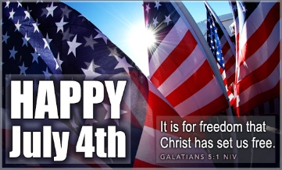
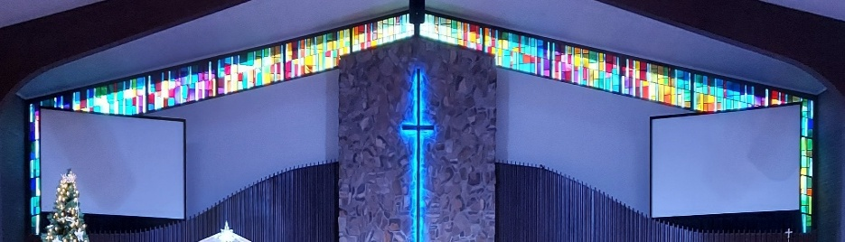
IMMANUEL LUTHERAN CHURCH

Immanuel’s Mission Statement
Immanuel exists to connect all people to Jesus Christ, who embraces all people in His grace, so that we can serve all people in love and discover a hope that heals.
The Sixth Sunday after Pentecost
July 5, 2026
Although the major focus of national celebration in the Year of Our Lord 2026 in the United States is the 250th anniversary of the signing of the Declaration of Independence, there is another memorable anniversary to be noted as well: 2026 is the 235th anniversary of the ratification of the Bill of Rights by the first US Congress. The very first words of the very first amendment within the list of additional guarantees added to the Constitution of the United States in 1791 known as the Bill of Rights states: “Congress shall make no law respecting an establishment of religion, or prohibiting the free exercise thereof.” That solemn guarantee enables us to gather freely to worship God without fear of disturbance or reprisal. As we gather, we can reflect on what a blessing religious freedom is ours in this God-blessed nation.
Happy anniversary, United States of America! It is time to rejoice greatly!

Today’s Hymns: LW 501, LSB 733, 805, 785 vs 1, 717 vs. 1, 895 vs. 1, 629, LW 295, LSB 965
Today’s Scriptures: Zechariah 9:9-12, Romans 13:1–10, Mark 12:13–17
Lay Reader: Kathy Hanke
Prayers of the Church for Today

Barb Ackerman receiving treatments in Chicago
Harriet Fester

Healing Needs for the Month – Please update the office with any changes.

Terry Graves, Sharon Korcek, Denny Lawrenz, Dorothy Ott, Renata Ottusch, Cheryl Petty,
Irwin (Irv) Poschke and Margaret Poschke,

Immanuel’s website

Rev. Dr. Douglas A. Krengel, Sole Pastor

Please contact Pastor Krengel for any Pastoral needs. If you would like to make an appointment with Pastor Krengel - You are invited to call him on his cell phone or send him an email or contact the church office.

Pastor Krengel’s Cell Phone: 832-257-5437 email: krengeld@gmail.com
Church Office Email: ilc@immanuelbridgman.org Website: www.immanuelbridgman.org (recently updated)

Sunday Services: Traditional 8:30 am, Praise 10:45 am
Worship Services are Streamed Live on Facebook - Immanuel Lutheran Church Bridgman
Sunday Adult Bible Study 9:30 am – ROOM 6

9650 N. Church St., Bridgman, MI 49106 269-465-6031 Church Office
Church Office Hours: Monday - Friday from 8:00 am – 4:00 pm

Welcome, guests! We have prepared a small gift bag from the back table to share with you.
Please take a moment to sign the guest book in the narthex so we can stay connected.
Thank you for visiting — we hope to see you again soon!



CHURCH NEWS

PLEASE NOTE: Summer Handbells Practice will be held at Trinity Glendora starting at 6:30 – 7:30 pm thru the summer.
It's 'Christmas in July' for Operation Christmas Child! Our donations have fallen off a bit the past 2 months, so the Outreach Board is praying for lots of items to fill lots of shoeboxes. In July we are collecting fun band-aides, wash cloths, nail clippers & files. The Dollar Store is a great place to find these items very inexpensively. And don't forget the clearance areas at Meijer's or other stores. All donations can be left in the decorated box by the Christmas tree.🌲
Bridgman Day is July 11, 2026 – We will be out on the front lawn from 12:45 – 2:00 pm. The Parade starts at 2:00pm, we will have a vintage truck in the parade for Immanuel, also the Praise Team will be singing in the front yard come and listen bring a yard chair, and we will have ice cream treats and water for the public. We would love help with setting up. And if anyone has a couple of pop-up tents we could borrow would be great – just let SueEllen Klein or the Church Office know. Thanks!
VBS 2026 – Theme Emerald Crossing – July 13-16 We are looking for volunteers! Please contact Shannon Jones if you are interested. Volunteer sign-ups are in the back of the Narthex, fill out and turn into the Church Office. Registration is Open to sign-up your kiddos and grandkids ages 4-12! Forms are in the back of the Narthex and can be turned into the Church Office.

Sunday, July 19, 2026 at 6:00 pm -- Trinity Lutheran Church of Glendora is presenting a concert of Reggie & Ladye Love Smith for an evening of worship in music. They are Grammy award-winning vocalists featured on Gaither Homecoming television specials will be held at the Howard Performing Arts Center, on the campus of Andrews University – 4160 East Campus Circle Drive, Berrien Springs, MI. Tickets: 269-471-3560 or 888-467-6442 or are available online at howard.andrews.edu $20 Adults, $10 Children 10& Under.

Saturday, July 25, 2026 from 3:00 – 8:00 pm Family Fun Festival at Christ Lutheran Church, 4333 Cleveland Ave. Stevensville, MI; Free Admission, Gates open at 3:00 pm, Stage performances with Live Christian Contemporary Music (Immanuel Lutheran’s own Praise Team will be there singing). Kid’s Zone w/bounce house, hands-on science edutainment for all ages, On-site Sarrett Nature Center hikes and talks, petting zoo, food trucks and more!! Bring your own chairs or blankets!

Church Picnic is scheduled for August 9, 2026!

The only thing better than eating a corn dog is working at the Korn Dog concession during the Youth Fair this August 17-22, 2026! Immanuel has usually sent numerous workers during fair week and we hope to continue to help. The shifts are 4 or 5 hours long, you get to meet lots of people, and you earn money for Immanuel's Outreach efforts. Sign up online at https://volunteer.ffbs.info or ask Amie in the office or Suellen Klein for assistance.

Patriotic Service is scheduled for September 13, 2026.

Bridges Bags are ready to check out and deliver in the back of the Narthex!

If you enjoy growing and sharing houseplants, you can help the Outreach Board by providing your plant offspring - please speak with Amie in the office or Suellen Klein.

Are you a good reader? Outspoken? Attend the 8:30 am Service? We are looking to grow our layreader pool? Why not jump in? If interested just stop in or call the Church Office!!

The Office is also looking for Confirmation Pictures for the following years 2000, 2006-2019 to add to the Confirmand Book! Any help is appreciated!

Last Sunday’s Attendance: 80 - 8:30 am, 40 - 10:45 am
Sunday Bible Study – 16
Thursday Bible Study – 6

Finance News

June 28, 2026, offerings and donations:
Offering Envelopes: $3,443.00 Year to date: $176,205.00

Thank You for your Contributions!
Electronic Giving is Available on Immanuel’s Website on the Main Page.
www.immanuelbridgman.org

